Balloon Wars: An ISR* Operator’s Account Of The Wars In Iraq & Afghanistan
* Intelligence, Surveillance & Reconnaissance

by
Robert Crimmins

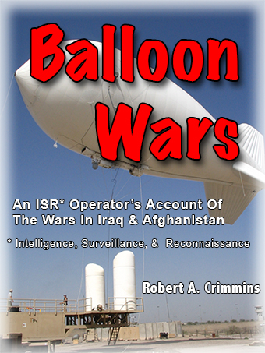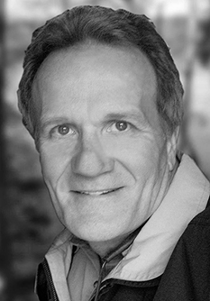

Robert Crimmins
5012 Killens Pond Road
Felton, Delaware 19943
302-632-4972
www.robcrimmins.com
rc@robcrimmins.com

© Copyright 2014
Robert A. Crimmins

Table of Contents
Table of Contents 2
1. Overview 5
2. About Rob Crimmins 6
3. Photos 8
4. Comparable Works 11
5. Marketing 11
6. Promotion 13
7. Chapter Outline 14
Book 1 Iraq 15
Part 1 – Site One On Camp Slayer, Victory Base Complex, May and June, 2007 15
Chapter 1 – PTDS Team 4 and the IRS Network 15
Chapter 2 – Unprepared 15
Chapter 3 – BWI to Baghdad 15
Chapter 4 – Vince and Winston Have To Wait In Ali Al Salem 16
Chapter 5 – Day One at Camp Slayer 16
Chapter 6 – Balloon Inflation 16
Chapter 7 – First Look at Baghdad 17
Chapter 8 – Meals By KBR 17
Chapter 9 – Without A Manual 18
Chapter 10 – The mIRC 18
Chapter 11 – Bootleg Software for the Troops 18
Chapter 12 – Battle in __________ (battle location deleted by DOD) 18
Chapter 13 – The FBI in Baghdad 19
Chapter 14 – Sectarian Violence 19
Chapter 15 – MND-B Headquarters 19
Chapter 16 – Site 3 Troubles 20
Chapter 17 – Muqtada al-Sadr 20
Chapter 18 – Judi’s Accident and the Balloon Loss 20
Chapter 19 – Team 4 Breakup 21
Chapter 20 – The Jackal 21
Chapter 21 – Barry 21
Chapter 22 – Morning Explosions 21
Chapter 23 – Jeff Goes to Site 3 21
Part 2 – Forward Operating Base Loyalty, July to October, 2007 22
Chapter 24 – My First Night at Site 3 22
Chapter 25 – Major Morris and Captain Hurt 22
Chapter 26 – OPSEC 22
Chapter 27 – Flight Director 23
Chapter 28 – Take Care of Yourself 23
Chapter 29 – Jeff and I Disagree 24
Chapter 30 – Rocket Attack With Judi 24
Chapter 31 – The Pool and Other Distractions 25
Chapter 32 – Fire Brigade and the Grenades 26
Chapter 33 – Urge to Jump 26
Chapter 34 – RETRANS Radio 27
Chapter 35 – A Million Shots in the Air and the Class System 27
Chapter 36 – Nightly Brief 27
Chapter 37 – The Gas Gauge 28
Chapter 38 – Working Groups, BDOC, Defense Network Hookup 28
Chapter 39 – The Sniper Accomplice 29
Chapter 40 – We Watch Mortars Launched at Us 29
Chapter 41 – Morris’ Planned Obsolescence Theory 29
Chapter 42 – Second Rocket Attack and Judi’s There Again 29
Chapter 43 – Kill Zone Analysis 30
Chapter 44 – RPG Hits Our Quarters 30
Chapter 45 – Programmatic Failures 31
Chapter 46 – EFP – September 1, 2007 31
Chapter 47 – Out of Iraq 32
Chapter 48 – Greece 32
Chapter 49 – Surprise! 32
Chapter 50 – “You’re Out! But first . . .” 33
Chapter 51 – A Sheikh Is Threatened 33
Chapter 52 – Letter to the Brigade Commander 33
Chapter 53 – Inflation at Site Three 34
Chapter 54 – Armed Forces PSAs 34
Chapter 55 – My Bosses and PMRUS Aren’t Pleased 34
Part 3 – VBC / Site One and FOB Justice / Site Four, October 2007 to May, 2008 35
Chapter 56 – Return To Site One 35
Chapter 57 – Site One Personnel 35
Chapter 58 – Illness 35
Chapter 59 – Matt Elliot 36
Chapter 60 – Road Trip 36
Chapter 61 – A Show About Nothing 37
Chapter 62 – Reassignment Request 37
Chapter 63 – Applause 37
Chapter 64 – Back to Business 37
Chapter 65 – 2000 Pound Bomb Dropped Near Dan’s Base 37
Chapter 66 – Ashura and Christmas 38
Chapter 67 – Icing 38
Chapter 68 – Fly Away 38
Chapter 69 – Out Of Iraq, Take 2 38
Chapter 70 – Paris 39
Chapter 71 – With The Army Again 39
Chapter 72 – Inflation at Site Four 39
Chapter 73 – After the Cease Fire 40
Chapter 74 – Russian Bride 40
Chapter 75 – My Son Joins Me 41
Chapter 76 – Wasted Asset 41
Chapter 77 – Computer Porn 41
Chapter 78 – UTAMS Project 42
Chapter 79 – Deadly New Weapon Fired On Loyalty 43
Chapter 80 – Going Home! 43
Chapter 81 – Delaware 43
Book 2 Afghanistan 44
Part 4 – Forward Operating Base Waza Khwa / Site W – June and July, 2008 44
Chapter 82 – Bagram and Waza Khwa 44
Chapter 83 – Pete 45
Chapter 84 – Another Rude Awakening 45
Chapter 85 – Their Own Pace 46
Chapter 86 – Captain Ellis 47
Chapter 87 – Ninth Inflation 47
Chapter 88 – Start of Operations at Waza Khwa 48
Chapter 89 – Getting By With Less (unnecessarily) 49
Chapter 90 – Auto Scan Ban 49
Chapter 91 – Ickbar 49
Chapter 92 – Polish KIA 51
Chapter 93 – Another Balloon Loss 51
Chapter 94 – Suicide Attempt 52
Part 5 – Fire Base Zormat / Site Z and FOBS Waza Khwa / Site W and Ghazni / Site D, August to October, 2008 53
Chapter 95 – Site “Z” on FOB Zormat 53
Chapter 96 – Equipment Misuse and Chaos During the Rocket 55
Chapter 97 – Troops at Zormat 55
Chapter 98 – FOB Selerno 56
Chapter 99 – Return To Waza Khwa 57
Chapter 100 – Ghost On The Wall 58
Chapter 101 – Workplace Violence and Humor 58
Chapter 102 – FOB Ghazni, The Site and Ghazni City 59
Chapter 103 – Doha and R&R #3 60
Chapter 104 – Spain and Portugal 60
Part 6 – Bagram AFB, Kabul, FOB Waza Khwa / Site W and FOB Ghazni / Site G, October to December, 2008 61
Chapter 105 – Life On Bagram Air Force Base 61
Chapter 106 – Kabul 63
Chapter 107 – Site Planning 64
Chapter 108 – Special Forces and Special Problems 64
Chapter 109 – Goodbye Waza Khwa 65
Chapter 110 – Dewey and Pat 65
Chapter 111 – Back To Kabul 67
Chapter 112 – Crosstown 68
Chapter 113 – Back to BAF 69
Chapter 114 – Lynn Weller’s Call From Home 70
Chapter 115 – Jim At Ghazni 71
Chapter 116 – Just Living 71
Chapter 117 – I’m Arrested 71
Chapter 118 – Last But Not Least 73
8. Sample Chapters 74

Overview
In May of 2007, the worst month of the worst year of the Iraq War for the Americans, I went to Baghdad to operate an airborne surveillance system for the U.S. Army. The Persistent Threat Detection System, PTDS (or “PeeTids”), is a camera and a weapons detection system on a balloon tethered thousands of feet above the battle space. I was the leader of a nine-man team that assembled the system on Camp Slayer on the Victory Base Complex and operated it, twenty-four hours a day in May and June as “The Surge” was ramping up. I then led a team in East Baghdad on Forward Operating Base Loyalty until the end of October when the introduction of new Army brigades in Baghdad had peaked. FOB Loyalty was near Sadr City and it was frequently attacked by the Mahdi Army and others. I watched those attacks, which were directed at me, and helped prevent others, from a vantage point unique in the history of warfare. Never before had the “high ground” been occupied in such a way and I was among a handful of American contractors and soldiers who witnessed it.
“Balloon Wars” is the account of those months and the time I spent in Afghanistan in 2008 as the war there was in its seventh year. It describes, in detail, how the system was operated, the things we saw and what it’s like to live on FOBs and firebases in enemy territory. I wasn’t prepared for it but I adjusted quickly. My wife wasn’t prepared either but she stood up to the difficulties as well as me and she was a part of them in ways spouses in previous conflicts weren’t. Twice, she and I were on Skype together during rocket attacks and she was with me in the same fashion many nights as we both dealt with our separation and her anxiety for me and our son, who was in Iraq with the Army’s 3rd Infantry division at the same time.
Psychological hardships and troubles from strange and unexpected sources can arise daily. Victories are much less common but much more important and the emotional costs and benefits abound.
The book takes the reader along, as the victories and costs mount, to three different bases in Baghdad during the worst phases of that conflict and to a dozen sites in Afghanistan and through the obstacles that I faced from the enemy, the elements, and most disturbingly from the Army, my bosses and the men I worked with.
The book has been submitted to the Department of Defense for security review. The decision to do that is one that all who write about classified projects face. Matt Bissonnette, whose pen name is Mark Owen, the U.S. Navy Seal who authored the book about the Bin Laden raid didn’t submit his book for security review. There are very good reasons for not doing so. I chose to submit my manuscript for review and for a while I regretted the decision because the first review was badly handled. It took months but I eventually succeeded in having the people in the Pentagon redo the review. The second time through they took me and my first amendment rights more seriously and returned a manuscript with far more content allowed. They also agreed that I may still appeal the redactions that remain. Originally they contended that an appeal wouldn’t be permitted.

About Rob Crimmins
Few people of comparable means can claim as many notable experiences as Rob Crimmins. He’s lived on both North American coasts, in nine states and in three countries. His first job, at the age of ten, was as a driving range attendant and dolphin show performer and his jobs and careers since have included engineering, nude modeling, demonstration skydiving, television news stringer, television producer, author, airship rigger, balloon operator and tradesman. The trades at which he’s earned a living are as a machinist, welder, window cleaner, caulker, mason tender and tower climber. (The full list is at http://robcrimmins.com/adventures-and-interests-2/jobs-list.) He’s a licensed pilot with single engine and sailplane ratings and a skydiver.
In 1980 Rob joined a project that would be the beginning of his on-and-off career in engineering and lighter-than-air (blimps, balloons and airships). Arthur Crimmins, Rob’s father, was the inventor of the Cyclocrane, a very unusual hybrid airship (http://robcrimmins.com/the-cyclocrane) . Art, Rob and as many as thirty others finished design and construction of what was the largest experimental aircraft ever built in 1982 to see it destroyed in a storm weeks before it was to take its first flight. They rebuilt it and flew it in 1984 and 1985. Rob was the co-pilot on the first flight.
Despite successfully demonstrating the feasibility of the concept the project failed and Rob went on to other jobs in the field. By the mid 1990s Robs experience in blimps and airships made him one of the top experts in the field and a design and project engineer with an impressive resume. He became a patent holder and lead designer or engineer on aerostat systems and components, the Shuttle Space Suit, an inflatable space station, and other aerospace inflatables. These titles and positions were earned and held despite having only attended art school for two years.
From the time Rob left college in 1976 until he went back to work on kite balloons in 2007 (after being out of the field for ten years) he wrote books, magazine articles, a screenplay, a stage play and much more. Cell 17: Interviews With the Imprisoned was self published in 1996, a history of the Delaware State Police (was published by the State Police Museum in 2002, and a biography of Benjamin Franklin, Lone Traveler: The Singular Life of Benjamin Franklin, was published as an e-book in 2014. It’s available on iTunes and Amazon.
In 2007 Rob heard about an application for one of the systems that he’d help design and field. Lawrence Livermore National Lab had developed the Persistent Threat Detection System with Lockheed Martin and it was being deployed in Iraq. “PeeTids” was a variation on a kite balloon system Rob worked on that carried radar and was mounted to a ship operated by the U.S. Coast Guard. They used it to catch smugglers who were bringing tons of cocaine into Florida in the 1980s. Rob was aboard the vessel during sea trails in the North Atlantic, as some of the first missions were conducted and when the vessel was docked in Guantanamo Bay. Some of the engineers and managers with Lockheed Martin were the ones who worked with Rob on the Coast Guard program so when he asked to re-join them they welcomed him back, trained him how to operate the new system and its payload (a million dollar camera and a weapons detection system), and sent him to Iraq. What happened to him there and in Afghanistan is the subject of his last book, Balloon Wars: An ISR* operator’s Account of the Wars in Iraq and Afghanistan. (*ISR - Intelligence, Surveillance & Reconnaissance)

Photos
I went to Iraq with the intention of recording the events, in writing, in photographs and with video so I took quality equipment and used it daily. I came back with thousands of pictures and hours of video. With them I produced a documentary, which is on Youtube. Many are on the web site about the book.
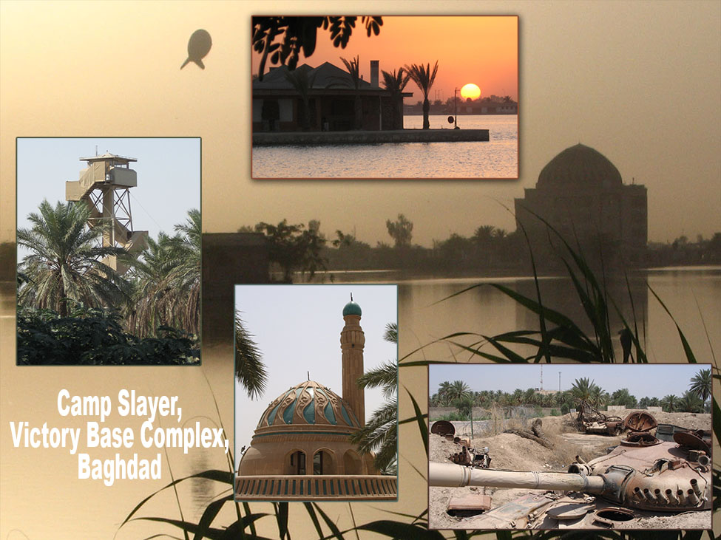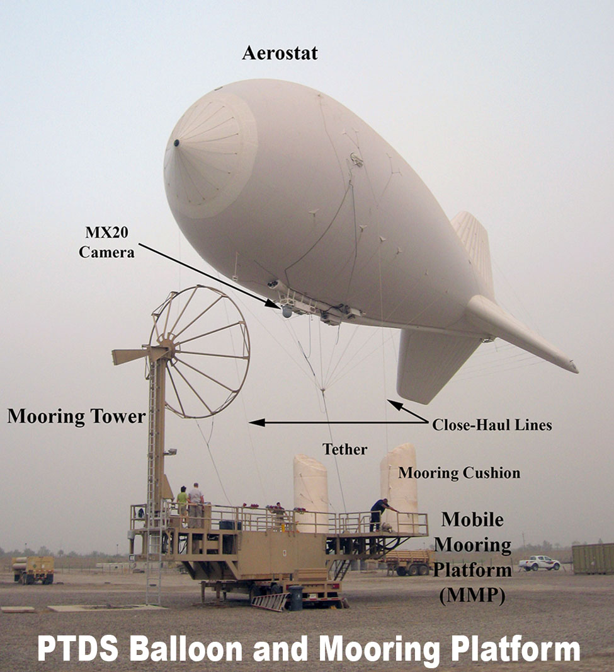
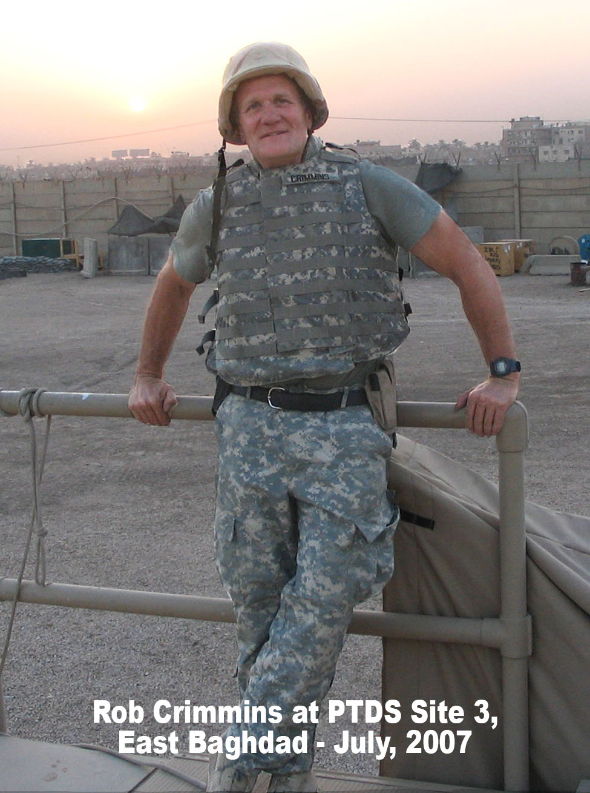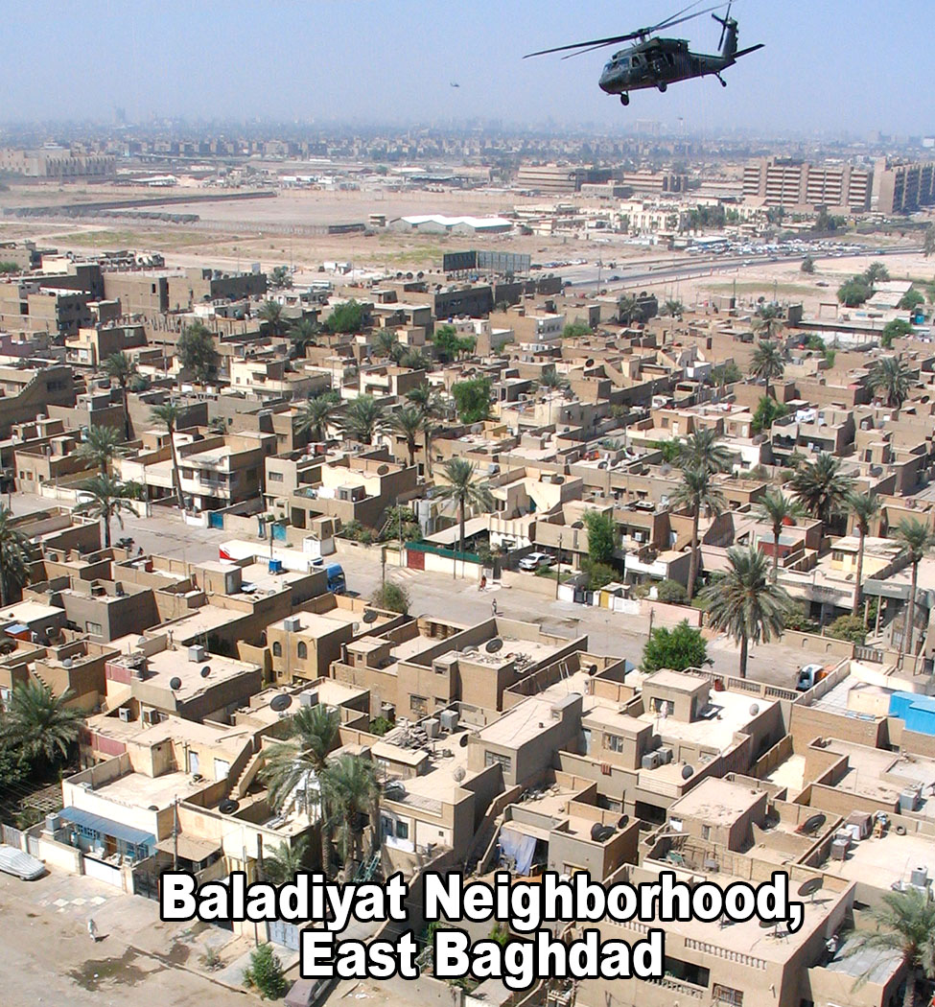
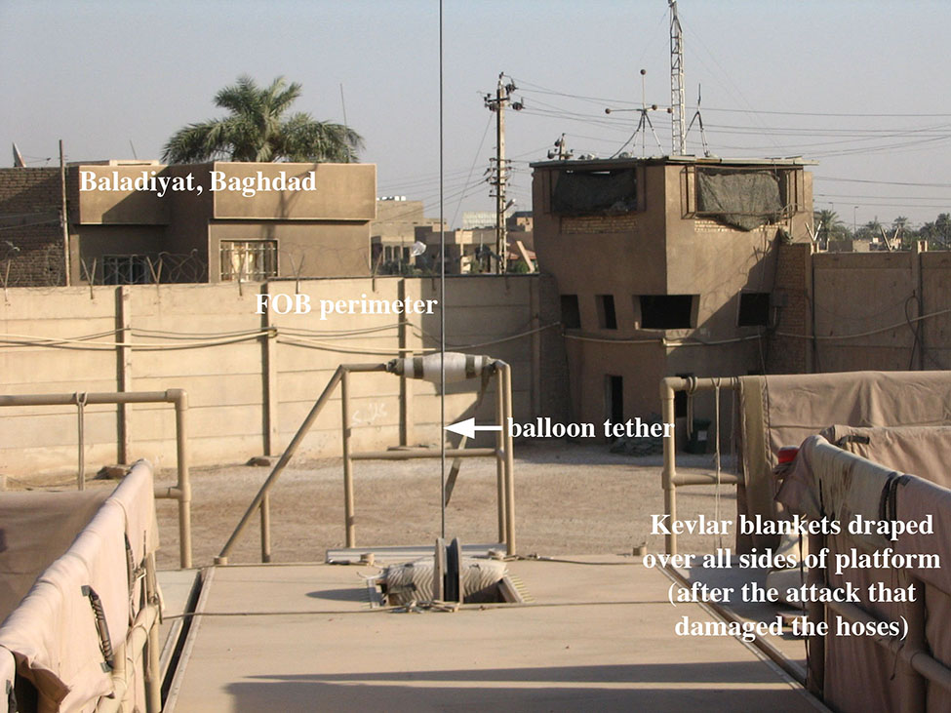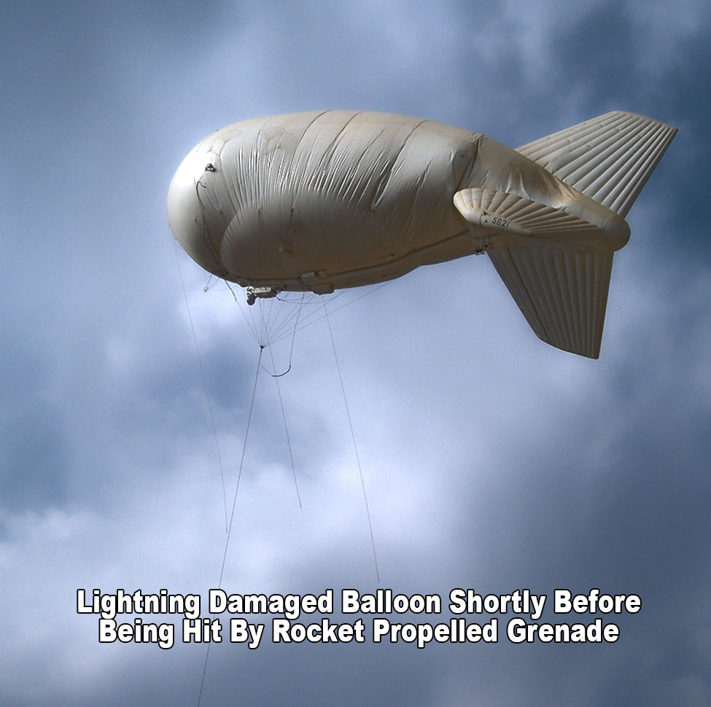

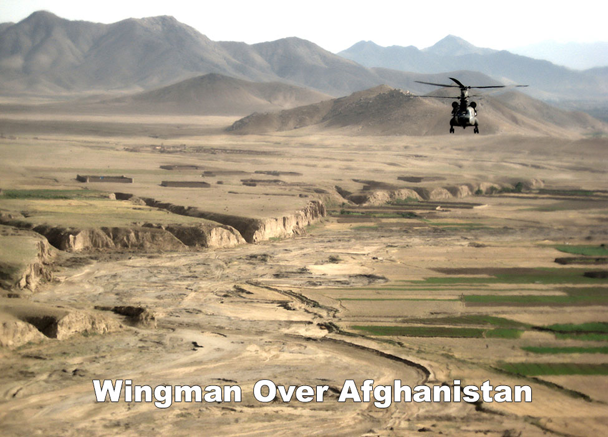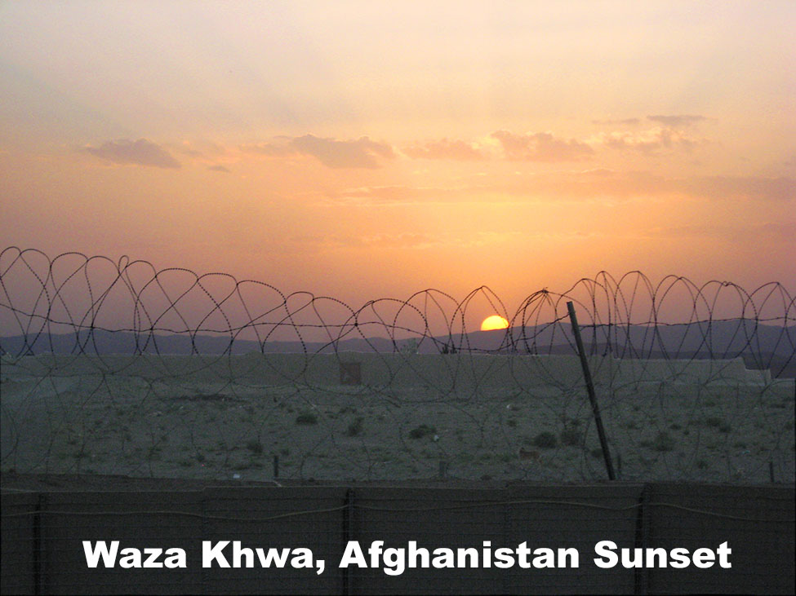

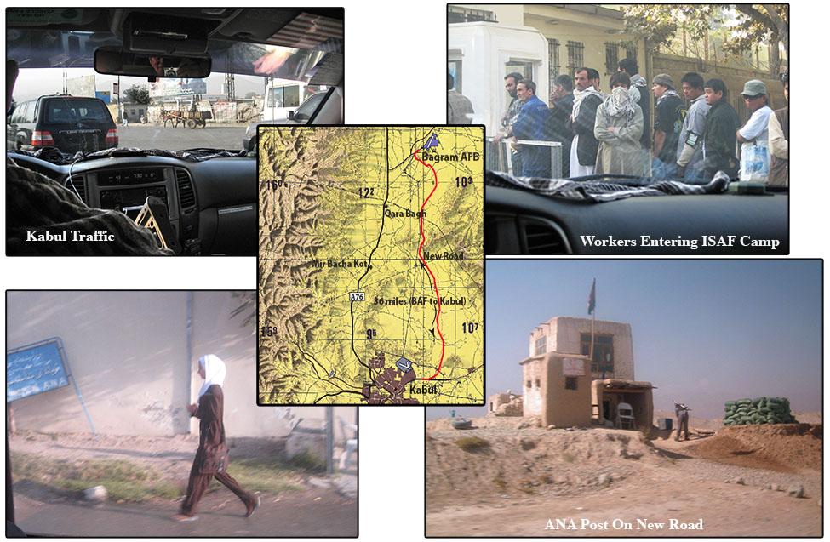

Comparable Works
  - “Fobbit” by David Abrams, ISBN 978-0-8021-9408-1 is a novel about the life of a U.S. Army public affairs soldier on a Forward Operating Base (FOB) in Iraq. I’d first heard the term Fobbitt from my son, an infantryman in the 3rd Infantry Division. He used it to refer to me while I was a contractor on FOB Loyalty in East Baghdad during the Surge. Fobbit is a derogatory term for anyone who never leaves the FOB. Although it is generally not used when referring to civilians, the life of the Army Fobbit is very similar to that of a civilian contractor, the difference being more in the nature of the work than the lifestyle.
  - “Inside the Wire” by Erik Saar and Viveca Novak, ISBN 978-1594200663 is like Balloon Wars in that both books are first hand accounts by principled men of their day-to-day experiences working on U.S. military secret programs. Both books offer unique insights into significant and historically important aspects of the War on Terror.
  - “Kaboom: Embracing the Suck in a Savage Little War” by Matt Gallagher, ISBN 978-0-306-81967-4, is a non-fiction book by an ROTC graduate who turned his blog into a book. He was in Iraq while I was there, during the Surge, and his book is similar to mine in that the incidents he describes each stand on their own, tied together by circumstances and context. My book is actually much more like a blog than “Kaboom”. Gallagher and his men were like the men that I watched and hoped to protect every day as I operated the camera above them. So was my son.
  - Although these books bear similarities to “Balloon Wars” there are no other books by authors with experience similar to mine, in programs that dealt so closely with the actual conduct of the wars in Iraq or Afghanistan.

Marketing
- One market is for those with similar, professional experience:
Hundreds of thousands of men and women went to Iraq and Afghanistan with KBR, Lockheed Martin, Raytheon, Haliburton, Blackwater and the other service and defense companies. Many of them will purchase “Balloon Wars” because our experiences were similar and little has been written about contractors. Also, nearly everyone, including the soldiers, in either war zone has seen PTDS balloons and wondered what they do. There haven’t been many reports of the tethered aerostats in the United States during the wars in Iraq and Afghanistan but they are a topic of discussion on every base, FOB and outpost where the balloons operate. They are ubiquitous in the war zones and whenever anyone heard that I was a balloon operator they invariably would say, “Yeah, I’ve seen those”, and then ask about what we did and how the system worked. For the soldiers who left the safety of their base the interest was frequently intense. During the time when they were most vulnerable we had an eye on them. If they could see an aerostat they knew we could see them, which had to be of comfort.
- PTDS is an integral and prominent aspect of the ISR network. Many war buffs and others interested in military tactics and history will want to add “Balloon Wars” to their libraries.
- Motion Pictures and Television
The book had to be written but the story may be best told as a movie or television series. The PTDS system is primarily a camera and our job was essentially television production, specifically event coverage and reality television in a much more literal sense than how that term has come to be used.
Every time we were on mission over watch or directed to a TIC (Troops in Contact) we witnessed men at war. We couldn’t hear them and we could only see the things that were on the camera’s line of sight but the action we were a part of, yet isolated from, was often extremely dramatic.
The young Americans who fought and sometimes fell beneath our camera were just like my son, who was fighting in Iraq the same time I was there. Those soldiers would be a character set in the movie. They would be the concern of the older men with me in our observation post a short distance away.
Those two groups would be the primary, perhaps only, character sets in the motion picture but the cable series could include the men and women in the Army’s Tactical Operations Center, Lockheed Martin and Army managers in the U.S., family of the PTDS operators and soldiers at home, Iraqi and Afghan civilians, Taliban fighters and Iraqi insurgents, and their families, friends and enemies. There’s tremendous potential for cultural comment.
The balloon operation is a visually fascinating subject. It’s a very large flying object that stays in the air through sandstorms and every other kind of weather. Shots from its vantage point, over Baghdad particularly, would be very compelling. When we recovered the balloon we would peer into the neighborhoods near us to watch for gunmen and those scenes could be exciting and revealing. Sometimes they were amusing and enlightening.

Promotion
- The Balloon Wars page on RobCrimmins.com provides a platform for the book. The sample chapters, journal entries, background information, pictures and video are resources for readers, researchers and journalists. I will respond to comments, update the posts and pages and otherwise maintain the site as needed to maximize sales. Links to the publisher’s pages, Amazon, ITunes and the other sellers will be prominent features.
- The documentary I produced tells the story of the writing of the book and it includes some of the thousands of pictures I took in the war zones. It relates how the events of September 11, 2001 affected my family. The documentary will be an important resource for those who may review the book or write about the author and it will be the basis for the presentations I’ll give.
- My professional experience in video production and my ability to build and maintain web sites means that I can create those materials or support their creation in valuable ways.
- I am a good speaker and look forward to promoting the book. My public speaking training was with the Dale Carnegie Course where I won the Outstanding Achievement Award for my class, which was large and attended mostly by business professionals and executives.

Chapter Outline
Balloon Wars: An ISR* Operator's Account of the Wars in Iraq and Afghanistan

From February of 2007 until mid-winter of 2009 I worked on a secret, United States Army program called the Persistent Threat Detection System. It's a tethered balloon with cameras and weapons detection systems that floats thousands of feet above the battle space. It only comes down when necessary and can stay aloft for weeks. The book is about operating it and what I saw from that vantage point and my life on the Forward Operating Bases in Baghdad during the most critical stage in that war and in Afghanistan before “The Surge” there.
The perspective we had was unique. In the history of warfare the high ground has never been occupied in such a way. The descriptions of what was happening on the streets of Baghdad from such a position are historically valuable but it's the setting for the other side of the story, which is what it's like to live in the war zone and the effect of that lifestyle on those who lead it.

Iraq

Site One On Camp Slayer, Victory Base Complex, May and June, 2007

PTDS Team 4 and the IRS Network
Nine of us, all middle class Americans in our forties and fifties, went to Baghdad together in May of 2007, was the worst month of the worst year of the war. We landed on May 5th.
The system we would assemble and operate, the Persistent Threat Detection System, was a large balloon tethered to the ground that carried an expensive and very sophisticated camera. It served a purpose similar to the one served by satellites, manned aircraft, drones, other balloons, tower cameras and other weapons detection systems. The network it was a part of doesn't include Special Operations, the CIA and people or units that are considered Military Intelligence but those operators and units depend on PTDS and the other assets to find and kill the enemy.
Conventional units use many of them for base defense and mission support too.

Unprepared
We weren’t prepared for the job when we got to Iraq. The training, which we received at Port Canaveral, Florida and at the Air Force Proving Grounds in Avon Park, Florida was good in some ways and very bad in others. We were taught how to assemble and operate the balloon, or “aerostat”, and the mooring system and how to operate the camera and all the devices and applications associated with it but we weren't instructed in how to conduct missions. We weren't told anything about how to use the camera and the other intelligence gathering systems and equipment, as it would be utilized to support the Army. I worried about those gaps in our knowledge and my efforts to fill them led to problems with my bosses and others.

BWI to Baghdad
Leaving home, especially saying goodbye to my wife, was hard, particularly since our son Dan was in the Army and already in Iraq. During his first deployment in 2005 he was in Ad Dawr, the village near Tikrit where Saddam Hussein was captured. The entire time he was there we feared the sedan with the chaplain in it would turn into our driveway. Now that I was going Judi would be worrying about her son and her husband.
The flight from Baltimore Washington International took us to Germany. From there we went to Kuwait City and then by bus to the Army LSA, Logistics Support Area, at Ali Al Salem Air Force Base. The “Embassy Flight” took us from the LSA to Baghdad. By the time I finally got to sleep, in quarters previously occupied by Republican Guard officers, I'd been traveling for thirty-eight hours. It would be the first of many such sleepless periods over the next two years.

Vince and Winston Have To Wait In Ali Al Salem
One of our team member’s bags was lost in Germany or Kuwait. They wouldn't let Vince go on without it or until it was declared lost. Winston had lived in Kuwait in 2004 and he even knew a little Arabic so he stayed behind with Vince I case he had to go into the city to buy clothes or gear to replace what was lost.
Vince finally got it straightened out but while getting off the bus to board the plane to Baghdad he fell and cut his head. It wasn't serious but he was bleeding so they wouldn't let him fly. He had to go to the infirmary and then get back in line for an available seat on the Embassy Flight or another aircraft to the VBC (Victory Base Complex).
At that point Winston left him behind and joined the rest of us in Baghdad.

Day One at Camp Slayer
Our house was on Camp Slayer, which was in a corner of what was Saddam's Abu Ghraib Presidential Compound. It was bombed during “Shock and Awe” and attacked by the Army’s 3rd Infantry Division during the invasion in 2003. Now it was part of the sprawling Victory Base complex and our temporary home. The prison of the same name is not on the VBC. It is about twelve miles west.
On Sunday, our first day on the job, the automatic weapons fire just outside the wall stopped when two Apache helicopters flew over and fired on the troublemakers. I asked one of the guys who’d been there a couple of years about it and he said, “So what”. It happens all the time.
As I got to the site that morning, before I’d even got out of the truck, I was startled by a very strong explosion just outside the wall, three hundred meters to the east. As the mushroom of dust, flame and smoke rose I thought of the Iraqi man or woman who may have thought he or she would be with their family later or the American soldier who had expected to be in the chow hall after returning from patrol who was, at that moment, injured or dead.
It was a large bomb but maybe it missed. The smoke and dust was all I could see above the wall and I realized within a few days the wall wouldn't block my view of the horrid results of such acts. Our million-dollar camera would put me out there as the dust was still rising and the victims screaming. We might help catch the triggerman or even prevent them from planting the bomb in the first place.
I wasn’t prepared for what I’d see and have to do.

Balloon Inflation
The “Kite Balloon” we were to inflate and operate had a volume of 56,000 cubic feet and is 110’ long so it’s no it’s no toy. The picture of the balloon in this chapter, with all the major components labeled will supplement the description and since there are men in the shot, the size of the balloon is clear.
There are problems with inflating the balloon in sight and within range of the enemy and there were issues with the personnel who were already on the site. The crew who was there before us worked for the company that Lockheed Martin was replacing and those men were going to lose their jobs to us. That aspect of our situation had momentous effect as the weeks and months wore on.
Information on the origin of the PTDS program is given in this chapter. There's also mention of how the lack of planning made our job much more difficult and dangerous than it should have been.

First Look at Baghdad
Inflation of the aerostat was delayed due to wind and a problem with the Army's (radio) Frequency manager but we were on mission just ten days after landing in Baghdad. Slowly rising above the city that the whole world was watching for the first time was thrilling.
The location of the original “Round City”, built by the Abbasid caliph Al Mansur in 762 on the west side of the Tigris isn’t far from Camp Slayer but no evidence of it remains. Floods, population shifts sackings by Mongols and Tamerlane and millennia of habitation have brought about multiple, significant changes to the former Abbasid imperial capital and once largest city in the world.
Seeing the roads, structures and canals outside the wall would make life inside much better. The people outside had to contend with terrible conditions but they were free. We were prisoners and watching people on the streets and in the markets lessened the feeling of confinement. As soon as the aerostat rose above the wall our world changed and with every foot of additional altitude it grew. Although a city in distress and different than home, it included children at play, traffic, animals and most of the other basic aspects of life we knew.

Meals By KBR
KBR (Kellogg, Brown & Root), Dick Cheney's previous employer, operates the dining facilities at the FOBs with large populations, over a few hundred. They do a lot of other work too. The DEFACs (dining facilities) are where contractors and soldiers can meet but at the large FOBs and bases we don't generally fraternize. I'd discover that our relationship with the Army could be different at more remote assignments.
KBR did great work at the dining halls and they were good at pretty much everything else they did too. They were facilities managers, mechanics, IT techs, carpenters, plumbers and just about every kind of tradesman you might need. They kept things running.
It was at a tremendous cost of course. Contractors are paid huge wages. Otherwise we wouldn’t go.
Marine Corps General Smedley Butler wrote after World War One that war is a racket and if you want to put an end to it make everyone, even the executives at home, work for soldier’s pay. If that were the case no one like me would go and business wouldn’t freely participate either. These days, if they aren’t casualties, even the soldiers reap the rewards of war.

Without A Manual
The system that we came with was everything that was needed for a PTDS site including the balloon, the camera and all the airborne equipment as well as the mooring platform, generators and the GCS (Ground Control Station), which is the shelter that housed the operators. The plan was for us to set up our system on Site One on Camp Slayer, operate it there for one month and then move it to a new site in north Baghdad.
While the setup was going on I was in charge but as soon as we started operating that changed because I knew nothing about conducting missions. The crew that had been there since 2004 knew everything. At that point all of us on Team 4 became students but without textbooks or manuals. Everything to do with mission execution, communications, tactics and techniques was imparted to us by the operators who we were to replace.
In some ways I didn't mind but there were also serious problems resulting from the conflict of interests.
Much of what they did was fine but there were ways in which the equipment was being misused so I wouldn’t do some of the things they wanted me to. For example, to catch bad guys doing bad things you had to scan the city the way a birdwatcher scans a field or forest. There are fundamentals common to all searches yet our instructors didn’t apply some of them.
Without basic oversight or quality control bad habits persist but it’s done in secret. The incompetent and lazy thrive in secrecy and the only ones who could see it were the Army personnel and other government people who used the video. With few exceptions, they didn't care either.
As I recognized the problems and corrected them, at least while I was at the controls, I became increasingly ostracized.

The mIRC
Communication between the GCS and the TOC, the Army's Tactical Operations Center, is conducted via the “mIRC”, which is the Internet Relay Chat. This chapter explains how that's done, my objectives when I was at the mIRC station and a mission during which it was done improperly.

Bootleg Software for the Troops
Iraqi vendors operate stores on the FOBs, doing things that are illegal and strictly forbidden in stores in other places.

Battle in __________ (battle location deleted by DOD)
I was operating the camera when a battle started near the site and went on for hours. It was the first action anyone on our team saw.
(Books and articles about classified programs are supposed to go through Department of Defense Security Review. Some authors and publishers bypass this step and get away with it. The best example is “No Easy Day”, the book about the Bin Laden raid written by one of the Seal Team Six operators.
I chose to go through the security review before trying to sell the manuscript and for a while I greatly regretted the decision. Initially the pentagon personnel and the people in the program office that the PTDS project was run from did a very bad job, ignoring my 1st Amendment rights. They even tried to prevent me from filing an appeal.
After many months I was able to have them re-examine their previous findings and conduct another review. The first time they redacted this entire chapter. Now, almost all of it, including still images from the video was allowed.
Most of the redactions in the first review have been withdrawn and my right to appeal them if I choose to, or if the publisher wants to, can still be exercised.)
The description of the Battle in __________ begins with the first shots and continues as the Iraqi Police return fire and the Sunni instigators fire mortars and RPGs into a Shi'a neighborhood. It continues as the weapons are hidden and ends when American troops, directed by officers watching the PTDS video feed, arrive and recover the weapons. Pictures taken from the camera on the balloon are included.

The FBI in Baghdad
CRC stands for CONUS Replacement Center and CONUS means Continental United States. It’s the place as well as the process that everyone going to work in the war zones has to go through. It takes a week and there are a lot of things to review, verify and obtain, among them are immunizations, first aid training, hostage survival training, aspects of the Code of Military justice, and cultural awareness. (The Muslim army Major who shot all the soldiers in 2009 did so at CRC at Ft. Hood.)
I met an FBI agent at CRC in Ft. Benning, GA and ran into him at the DEFAC on Camp Slayer. He told me how standard investigation methods are used to find insurgents who plant IEDs and commit other crimes.

Sectarian Violence
I watched three young men fire an anti-aircraft gun, without taking aim, into a neighborhood from a second story rooftop. They just fired randomly over the rooftops and into houses in the adjacent neighborhood. It was a heavy weapon made to destroy aircraft so firing it into homes with no control of what the rounds penetrated other than “God's will” was an act of pure and terrible evil.

MND-B Headquarters
The command center at Multi National Division – Baghdad was the hub of operations for the war in Baghdad and where Generals Odierno and Petreus spent part of their time. The PTDS video was the most prominent live image on the big screen in the amphitheater. There I saw how a hundred men and women from every service branch monitor the war.
PMRUS, which stands for Program Management Robotics and Unmanned Systems, was the Army office that ran the PTDS program. Their representative took me to MND-B Headquarters and I lived with him for a while the following year. When I tried to engage him in a discussion of books we were reading he told me that he doesn't read books anymore but when he did he read them backwards.
There are several accounts of bizarre behavior like this in the book. The pitch for the movie could be “M*A*S*H or Catch 22 at “The Office” in Iraq.

Site 3 Troubles
While we were settling in to our lives on Camp Slayer the men on “Team 3” at Site Three on FOB Loyalty were struggling. They were in one of the worst parts of town and a favorite target for many of the Mahdi Army cells operating out of Sadr City. In several ways their situation was dire.
The enemy was the worst problem but there were many other factors that made living on the FOB and operating the system nightmarish. We had a daily conference call between all the sites, our offices in Florida and Akron, Lawrence Livermore National Laboratory and CENTCOM in Tampa so I heard about Site 3’s hardships as they were reported on the daily call. It wasn’t on a secure network so they couldn’t tell us everything but from what they were able to say and from the emotions in their voices and from the way personnel were quitting and being replaced we all knew they were miserable.
The Army’s purpose and tactics during the surge could have been enhanced with PTDS services and eventually it was, but while Lockheed Martin struggled to get the system functioning properly it was a burden and a hindrance rather than an aid.

Muqtada al-Sadr
Muqtada al-Sadr was a very important figure in Iraq. The militia he led, Jaysh al-Mahdi (JAM), had been attacking Americans since 2004 and by 2007 it was the coalition’s primary antagonist in East Baghdad. Chapter 17 introduces Al-Sadr and explains how he came to have such a strong influence on Iraqi national politics and day-to-day life on the balloon sites.

Judi’s Accident and the Balloon Loss
On May 29th Winston and I were outside working when we heard gunfire and bullets whiz by us. We ran for cover and called the BDOC (Base Defense Operations Center). They didn't care.
I decided I could wait until after dark to go back outside but before I did I called Judi. She didn't answer but I knew that she going to see my brother so I called him. David told me she had just been in a serious accident and although he spoke to her right after it happened, while she was still at the scene, the call was dropped before she could tell him her condition. She did tell him that the car rolled three times. It was very scary news. I called her again but didn't get an answer.
There was nothing I could do so I went to work in the mooring platform. The weather forecast was for strong wind so we recovered the balloon earlier in the day and it was on the tower. Minutes after going outside the wind picked up and quickly became a gale. What we learned later to be a tornado swept the site and put enough load on the balloon to break the mooring tower. The balloon fell with the tower causing severe damage. The aerostat itself was beyond repair and there was extensive damage to the airborne equipment as well as the mooring system.
In the midst of that crisis Judi got through to me and told me that except for a sore neck (which turned out to be an avulsion fracture) she was OK.
We assumed Dan and I were the ones to worry about and then she was the one who almost was killed. Since bullets had narrowly missed me earlier we both had close calls that day.

Team 4 Breakup
While I worked on inventorying the damaged equipment and replacing it some of my teammates were sent to Site 3. Barry, Rick, Bill and Don were sent to FOB Loyalty to fill in for Team 3 members who were going on R&R, quitting the project or being forced out by the Army and Lockheed management. The ones being forced out were the Site Leads. Four had been replaced in just five months at the request of the Army major who was in charge of the PTDS site and crew.
As soon as they got there Rick and Bill put sandbags around the GCS and on the roof.

The Jackal
The Victory Base Complex is over twenty square miles of military / industrial wasteland, man made lakes and poorly built, architecturally ridiculous homes and palaces. It was a strange home and our view of it from the camera on the balloon and the many trips to all corners of it made one that I came to know extremely well. This chapter is an E-mail to Judi about taking a colleague to Sather Air Force Station on the far side of the VBC and what that trip consisted of.
The wildlife on the VBC is scarce but includes jackals. Seeing that biblical creature in such a hostile and unnatural setting was an unusual aspect of that particular trip.

Barry
Barry was one of many strange and insecure personalities I’d encounter and be forced to figure out.

Morning Explosions
Being awakened by automatic weapons fire and explosions became a recurring and disturbing theme, one that provided clear insight into post traumatic as well as real time stress. (In one email to my boss I wrote, “I’m not putting it off! Post Traumatic Stress Disorder is procrastination. My stress is happening right now!”)

Jeff Goes to Site 3
Shortly after Barry, Rick, Don and Bill went to Site 3 Major Morris asked that the Site Lead be replaced, again. If I hadn’t been rebuilding the site after the storm I think they would have sent me but since that wasn’t an option they asked Jeff if he would do it and he agreed. A few weeks after he got there a rocket landed on the site while four of them were on the platform. Jeff called our boss immediately and said if they didn’t get him out of there he’d quit. It was so bad that one of the crewmembers took to wearing his helmet and ballistic vest all the time and staying in the bunker whenever he wasn’t operating the equipment.

Forward Operating Base Loyalty, July to October, 2007

My First Night at Site 3
The plan for Team 4 was out the window by the beginning of July when Winston and I were ordered to go to Site 3 right after the replacement balloon was inflated at Site 1. We were on different flights. Mine was unlike any other I’ve ever been on and since I’m a pilot and a sport parachutist I’ve been on many. The Blackhawk, carrying M60 gunners on both sides and firing counter measures flares, cleared the north wall of the VBC a little after midnight. We made several stops before I got off with two others on a dark and completely unmanned landing zone a couple hundred meters from the balloon site.
No one was there to pick me up so I hitched a ride on the HMWV that was there to get the two soldiers.
That night I patched holes in the balloon from the basket of an aerial lift thirty feet above the perimeter wall and in clear view of a Baghdad neighborhood known to be extremely hazardous to Americans and their supporters.

Major Morris and Captain Hurt
The next day, July 4th, Jeff took me to meet our Army handlers. Captain Hurt had developed a hatred for the balloon crew so he wasn’t even slightly amiable but Major Morris, the “Force Protection Officer”, who was the one in charge of our operation, took a liking to me. So much so that he told my boss, immediately after that first meeting, to make me the site lead, which he did. The guy who was replaced wasn’t particularly surprised, because he’d seen four site leads come and go, but I was.

OPSEC
We needed our managers and the engineers in Florida and Akron every day to help us with equipment and systems we weren’t familiar with, which meant they needed to know what we were doing and why we were doing it. However, because of the rules on OPSEC, “Operational Security”, what we could divulge on non-secure channels, and all communication with any one who wasn’t on the SIPR (Secure Internet Protocol Router) network was non-secure, was limited. Without the freedom to describe what was actually taking place it was impossible to fully convey the distress and urgency we felt. It might be apparent in the anger in my voice but without being able to explain why I just sounded like a hothead rather than someone who was justifiably desperate.

Flight Director
“During my shift I was the Flight Director, the one to decide when it was safe to operate the balloon. I didn’t determine whether or not to launch or recover the balloon, that was the Army’s decision, but I had to tell them when it was or wasn’t safe to do so. And I had to know when it wasn’t safe to remain airborne.
The Flight Director has to know the conditions at his site and the mission requirements. He has to know the weather and the forecast at all times, what condition the equipment is in, what’s the helium volume in the aerostat and how much is available on the ground and many other things. There were a lot of things I had to know about Site Three and until I knew them the system was at risk. I wasn’t satisfied with my knowledge or my abilities to operate a kite balloon, anywhere, let alone in an active war zone. I’d done it before but it was twenty years ago and then only briefly. I wasn’t in charge then and it was on a ship in the Atlantic. I sure didn’t know what I was doing in Baghdad in the middle of a war.”
These are the first two paragraphs of the chapter. The rest of the chapter gives the reader a good feel for what my main problem would be for the near future. I had to know the condition of the balloon and how to manage all the things that were dependent on that condition.
The most important things I already knew was that the balloon had never been in the air continuously for more than six days yet the contract called for continuous operation, at mission altitude, for three weeks and that on more than one occasion the balloon was recovered because the crew had let it remain airborne until the wind stopped and it was no longer lighter than the air around it.
The enemy and / or vandals had managed to hit the balloon with small arms fire, almost certainly AK-47 rounds, and it was leaking. The previous flight directors, including Jeff, had no way to know when the balloon was no longer buoyant other than tether tension. Since it’s a “kite balloon”, one of the components of tether tension is the wind; the other is the lifting gas. If you can’t quantify at least one of those values you won’t know when there isn’t enough gas in the balloon to keep it up when the wind dies. At that point, if it isn’t reeled in, real fast, it will fall to the ground.
That happened a couple times and both of those events qualified as emergencies, something the Army really hates in the middle of a war.

Take Care of Yourself
Lockheed and PMRUS had decided that the ideal PTDS operator would be an A&P (Airframe and Power plant) Mechanic. I wasn’t an A&P but my other experience made me far more qualified than many of the others. Most A&P mechanics are members of unions and employees of airlines. Many are retired from the military. As such they are used to being watched over pretty closely and bound by rules that are pretty rigorously enforced and they’ve spent years in paternalistic organizations so they’re accustomed to having many of their needs cared for in exchange for their expertise and service.
I already knew that many of those in the PTDS program expected others to take care of many of the details of their existence. Jeff felt that way and would spend a portion of his time helping others with time sheets, travel arrangements, housing, e mail access, employee benefits and myriad other minutia that I felt people should do on their own.
Shortly after I got settled in my new job I held a meeting and told the crew not to ask for my help with such things. I also asked for their cooperation with correcting the problems they knew we had but by then they had already decided what they would and wouldn’t do for anybody. I decided not to hold it against any who wouldn’t cooperate until I had to, which didn’t take long.

Jeff and I Disagree
When we were in Florida for the training Jeff and I lived together and became pretty good friends but the friendship became strained at FOB Loyalty. After the crew meeting we argued about whether or not I should help people with their personal stuff. He felt I should but if I did I’d be accepting responsibilities that would interfere with what I had to do, which was to get the site in order and start meeting the requirements of the contract. Jeff retired from the Army as a sergeant shortly before joining Lockheed Martin so he had no experience with complying with technical contracts. In fact bringing that up made him angrier. To him it was taking “their” side.
Jeff’s demand to be relocated from Site 3 was met and I replaced his replacement but he couldn’t leave the site immediately. That’s why he was still there for the meeting. He did fly out a few days later but he didn’t speak to me much before he left.

Rocket Attack With Judi
One of the good things about Site 3 was high bandwidth Internet, which made video chats with people back home possible. Judi and I used it frequently and if we didn’t do something noteworthy with the camera those calls with her were the best part of every day.
During one of the first I was in the TMOS (Transportation, Maintenance and Operations Shelter), which was a climate controlled shipping container like the GCS where we stayed when we were on shift but not operating the camera or mIRC. Judi and I were enjoying the new amenity when a rocket landed on the site no more than a hundred feet away. The explosion was very loud and Judi heard it clearly. She asked, “What was that?” and I told her it was either an incoming rocket or mortar or an outgoing one. The mortar team that launched 120 mm mortars pretty regularly was right next to the balloon site so it could have been outgoing. I didn’t know. Bill was outside so if it was an incoming round he was probably within the kill radius. Without telling her the details I ended the call and went to check on Bill, which would be dangerous if it was an attack. When the enemy fired on us it was often multiple rounds but if he was hurt I wanted to get to him quickly. As I was about to open the door he came in and verified that a rocket had just hit the site about fifty feet from the platform.
We called the BDOC to tell them where the round landed so they could send the analysis team and we stayed inside for awhile to be sure no more rounds were coming. Then we went outside to evaluate the damage.
The mooring cushions, which are large, inflated cylinders that bear on the balloon when it is on the tower were riddled with holes. It was our habit to leave them draped over the handrails when they were deflated which exposed them to the blast. From then on I never left them like that. There were also numerous holes in the platform walls. Amazingly, the only damage I found inside the platform was two cut hydraulic lines.
With the lined cut we couldn’t recover the balloon so they had to be fixed. so although I was at the end of my twelve hour shift I started looking for the parts to build the replacements. Because there were so many damaged vehicles from IEDs and Explosive Formed Projectiles (EFPs) the motor pool was well equipped and they had the hose, fittings and tools I needed. It took me six hours to pull it all together and install the new hose.
The working conditions were about as bad as they could be. The outside temperature was 130 degrees so it was like an oven inside the platform. By the time I finished and was able to turn on the motors that ran the pumps I was whipped.
They say in the desert it’s a “dry heat” as if that’s better. It isn’t. It’s the kind that will kill you.

The Pool and Other Distractions
There weren’t many distractions from the routine and the difficulties on FOB Loyalty. The video chats with Judi was the best one but another very good diversion was the pool. It was in a metal building on the south side, almost against the wall. No one mentioned it before I got there so when I discovered it I was very pleasantly surprised. Swimming is my favorite form of exercise and for the previous couple years at home I’d been swimming daily in the high school pool down the road from our house.
After leaving my shift at 1000, or later if I had to work overtime, I’d go to the pool and swim a mile. Leaving there in the blazing heat and sunshine after a hard swim felt great and in the afternoon sleep came very easily. It was why I was able to establish and keep a steady sleep schedule there. In most of the places I worked afterward I couldn’t.
On two occasions there were mortar attacks while I was swimming and with my head in the water I couldn’t hear the alarm. The attendant, an Indian gentleman who took outstanding care of the facility, shouted and waved his arms until he got my attention before he ran out to the bunker, which was pretty brave. I followed him, running in shower shoes over the ankle busting size stones they spread around just about everywhere.
I was somewhere else on the FOB the day the pool building took a direct hit from a 60 mm mortar. Fortunately the roof was stiff enough to cause it to detonate rather than pass through and explode on the pool apron. Shrapnel hit two soldiers but no one was seriously hurt.
Another distraction Judi provided was a quart of Crown Royal® in a Listerine® bottle. I came to miss my usual cocktail after work so I asked Judi to send some whiskey but to be sneaky about it. American contractors and soldiers were not allowed to have alcohol. Brits, Germans and others were but not us. Later I learned that breaking the rule was a serious offense and anyone caught with booze would be fired so we only did it that one time.

Fire Brigade and the Grenades
There was a fire in one of the Iraqi retail shops on the FOB and the fire brigade asked for our help. This chapter is about the crazy things that happened that night including the mortar attack during the emergency, the need to take cover in the burning building, crates full of grenades in the burning building in which people were taking cover and fighting a fire with a pump sprayer (the kind used for spreading insecticide).

Urge to Jump
The conditions and problems caused by the leaks in the balloon were intolerable to me, and “the customer” (the term for the Army used most by the managers in Florida). Jeff and the other site leads before him dealt with it by bringing the balloon down and adding helium when it was needed but that was an unacceptable solution because it couldn’t be sustained. Leaks don’t just let helium out, they let air in too which contaminates the helium. Eventually the amount of air in with the helium is so great it is no longer a lifting gas. At that point the helium can be purified, if the equipment is available, which it wasn’t, or the balloon has to be deflated and re-inflated with fresh gas. That is an expensive procedure in many ways.
I was determined to find the leaks and patch them, a tedious, difficult and dangerous operation, but one that simply comes with the job. If you want to fly a helium balloon you have to stop leaks.
The second leak inspection, which we couldn’t do until about a week after the first because of the wind, went well for the first few hours. There were two of us in the basket and after a few hours we found and patched several leaks. I had just stopped worrying about the hundreds of windows and scores of rooftops just beyond the wall when we were fired on. Tracers came from the neighborhood beyond the wall, continued past the guard tower and then right by us. They may have been directed at the tower but they were close enough for us to hear them as they went by, which is a sound that induces panic.
It’s hard to imagine a more vulnerable position. Sixty feet in the air in an open basket, that can only move a few feet per second, at night, with a bright light in your hand. Of course I turned the light off right away but the only quick escape was to jump and the urge to do that was pretty strong. It must be just like it is for people in burning buildings. Two broken legs would be better than a burning 7.62 mm round hitting me just about anywhere.
We resisted the urge and got as small as we could for the impossibly long and slow ride to the ground.

RETRANS Radio
The balloon is 117’ long and 39’ at the max diameter with strobe lights and tether pennants so it is a very prominent feature in the sky. At Site 3 it’s in the middle of the city. The enemy can see it at all times and they know exactly where it is attached to the ground. It’s visibility to the enemy was the source of many hardships but they weren’t the only ones who noticed the balloon who made my life more complicated.
Some Colonel (I never knew his name) looked up one day and decided he wanted to put a radio on that balloon up there to help units on the ground communicate with each other. It wasn’t a bad idea but attaching another payload to a leaky balloon that was often floating with very little free lift was.
We did it anyway.

A Million Shots in the Air and the Class System
Major Morris didn’t particularly care if we were killed. That was a fact and his distaste for contractors was fairly typical. To him it must have seemed our own managers felt the same way because they had already demonstrated that the Site Lead could be replaced within hours, making me literally more dispensable than Major Morris’ computer. He was concerned for the “asset” however so from the night we were fired on and had the urge to jump he’d arranged for patrols to be out during leak inspections. On two occasions they even had attack aviation overhead, two Apaches doing tight circles outside the wall the whole time the balloon was on the tower.
Because my job was important and I’d seen the bravery of the soldiers as they conducted their missions I was willing to take the risks that the Army demanded, until July 29. We were scheduled to do a leak inspection that night. Everyone on the night shift who was willing to work above the wall had done so by then. I was the only one who went up every time. The others took turns.
On Sunday, July 29, Iraq’s national soccer team beat Saudi Arabia in the Asian Cup Final. I was glad the Iraqis had something to celebrate but the form of the celebration included firing every weapon they had into the air. After the semi-final victory over South Korea and then on the 29th, when they beat the Saudi’s it was amazing. There might literally have been a million rounds fired after those two games.
Being fifty feet in the air holding a bright light while thousands of men were expressing their thrill of victory with firearms seemed an unreasonable risk. I called Morris late in the day, while the shooting was at its worst and asked him if he agreed that we shouldn’t bring the balloon down. He didn’t. I didn’t argue but if the shooting hadn’t stopped I would not have done it. Fortunately, one hour before the recovery was to begin the shooting stopped and I didn’t have to refuse the order and lose my job. But I was afraid. Once again, there would be no postponing the stress.

Nightly Brief
Every night at 2100 I attended the Commander’s Brief, which was held in the Tactical Operations Center, during which the FOB Commander, Lt. Colonel Dunham, was briefed by all his subordinates. It was a management exercise just like many others I’d held and attended in my careers and it lasted about an hour. Unlike the others I’d attended in the past the subjects each presenter was responsible for at the Commander’s Brief were matters dealing with conducting a war.
I was inspired, appalled and fascinated by what I heard.

The Gas Gauge
In the first few weeks after I got to Site Three and realized that I needed a means of predicting when the aerostat would be out of helium we had several opportunities to lose the balloon due to loss of lift. Every time that condition occurred was a chance to gather tether tension and wind data when lift was low and when it was high. The wind had varied considerably too, sometimes blowing over sixty knots, so all the data I needed on that parameter was available too. Unfortunately, there was no automated method to record the data. At that time, although the “State Of Health” data was constantly displayed it wasn’t recorded. The only way I knew of to record it was to have the screen capture utility save the screen at every few minutes and manually enter the data from that image into a spreadsheet.
I had a crew member do that and when enough data was gathered and entered I was able to create a chart that plotted tether tension at all wind speeds for the balloon with both maximum and minimum helium volume. I made a plot of those two lines and posted it next to the “State of Health” monitor. From then on all I had to do was read the current tether tension and wind speed to see if the intersection of those two values was above the line for that wind speed at minimum helium volume. If it was well above that line we weren’t in danger. If it was near it I knew I’d have to recover the balloon soon.
It helped a lot, particularly when we finally patched all the holes. By the time it was over we had found and repaired dozens of bullet holes and were able to keep the balloon in the air for long periods, the longest being twenty-five days, a program record. When the balloon was overhead and out of harm’s way for weeks at a time my life was much better.

Working Groups, BDOC, Defense Network Hookup
The Iraq War and insurgencies in general involve asymmetrical warfare. An actual example was the destruction of an MRAP (Mine Resistant Ambush Protected vehicle) by an IED outside the FOB one afternoon. The vehicle itself was destroyed, two of the occupants were killed and two were severely injured. An MRAP costs a million dollars. Each death is a million dollar loss, more or less, and fixing or trying to fix the wounds and lives of the injured could easily cost a million dollars each as well. That’s a five million dollar expense from a weapon that might have cost five hundred dollars. Ten thousand to one is the ratio, roughly what Bin Laden was hoping for.
“Working Groups”, had been formed to reduce such asymmetrical losses and Major Morris suggested I join two of them, The Counter IED Working Group and the Counter IDF Working Group. One was a serious attempt to defeat the enemy and save lives and the other wasn’t.
Like the Nightly Brief the meetings those groups held and the work they accomplished had a lot in common with the practices of successful and failed businesses. The fact that the Army held them inspired me to pursue other improvements.
Some of those efforts are described in this chapter and for those who are familiar with the networks and systems mentioned those descriptions will be enlightening. For those that aren’t familiar enough definition is provided to make it interesting too.

The Sniper Accomplice
Diligence, and a fascinating sequence of events lead to the capture of a murderer’s accomplice.

We Watch Mortars Launched at Us
A camera on a stationary balloon thousands of feet above the battle space captures amazing scenes. On this occasion we saw mortars fired, counted the seconds until they landed on the FOB, each one nearer to us, and then watched the mortar team’s flight through rush hour traffic. Finally we witnessed their destruction.

Morris’ Planned Obsolescence Theory
When you think about it, it’s as bizarre as reading books backwards.
One day Major Morris and I happened to be in line for lunch at the DFAC at the same time so we sat together. While discussing a mission that had gone badly he repeated an aphorism he’d said the first time we met.
“The first rule of war is, young men die”.
The first time he said it was shortly after I told him that Danny was in the Army in Iraq, in a combat unit. The topic had changed so he wasn’t saying my son could die, exactly, but it was still insensitive. He was being George C. Scott as Patton, and actors are everywhere so I ignored it. Afterward I thought he said it to show that he was not just cold in general but indifferent to me in particular but that wasn’t the reason. Officers make mistakes that cost lives. Blaming it on the rules relieves the guilt. Morris did it automatically so he didn’t even identify the mistake much less process it into a useful emotion, but that wasn’t the bizarre behavior.
He told me that American manufacturers design their products so that regular service and repairs are needed, not an original theory of course. He cited General Motors and Lockheed Martin as examples, GM, because cars need maintenance and replacement parts more often than necessary, and my company because it’s hard to find and repair holes in the balloon fabric. I don’t think he’s right about GM but I know he’s wrong about why the balloons need repairs and why it’s hard to find the holes. And so did he!
It was an important moment in our relationship. The engineering and design conditions and limitations are simple but as I mentioned them he countered by citing his business school credentials. His idea that Lockheed intentionally made the balloons hard to repair, and was therefor corrupt, was so irrational I thought at some point he would reveal he didn’t mean it, that he was being some sort of devils advocate. But he did mean it, and he didn’t like me disagreeing with him.

Second Rocket Attack and Judi’s There Again
Rick installed an Ethernet connection in the bunker just outside the GCS for a private place to call our wives or conduct personal business. One morning I was sitting in a chair outside the bunker chatting with Judi.
It was a couple of hours past sunrise in Baghdad and early evening in Delaware. I could hear the morning traffic just outside the wall. The sun and heat were rising and I was looking forward to the end of my shift at 1000.
A rocket passed directly over me so Judi and I both heard the whoosh of the motor and then the explosion as it smashed into a gas station just outside the wall. There was an article in Stars and Stripes about it but I found out before it was revealed in the paper that thirteen Iraqis were killed.
As soon as I heard it I pushed myself over backwards in the chair to get on the ground. As I did the computer slid off my lap and landed in the sand. It wasn’t damaged so after the blast I heard Judi calling out. She wasn’t panicked but she was pretty excited.
I picked up the computer and pointed it at me so she could see I was all right but I was wearing my sunglasses around my neck and since she was expecting an injury Judi thought the object on my chest was blood and I’d been hit. Then she did scream but realized almost right away what she was seeing.

Kill Zone Analysis
One member of our team refused to work the day shift because of the frequent mortar and rocket attacks. I did research into the munitions the enemy used to see just how dangerous they were in the hope that I’d find the odds of being injured or killed weren’t as bad as he thought. I found out he was right. If you were on the balloon site when a 120 mm mortar or a 107 mm rocket landed on it you would almost certainly be within the blast radius and if the round was an 81 or 60 mm mortar the chances were still high.

RPG Hits Our Quarters
One afternoon, after an extremely difficult fourteen-hour shift the water stopped flowing in the middle of my shower while I was completely lathered with soap. After putting on underwear I went to the nearest quarters for bottled water to rinse off. I ignored the soldier who, seeing my condition, still objected to me taking his water.
From their I went to my quarters and one hour after lapsing into very deep sleep an RPG hit the building on our floor and about forty feet from my bunk. The concussion and thunder filled the room and my skull and despite being soundly asleep I comprehended the astoundingly complex sound of the projectile penetrating the concrete and shattering it, the shrapnel and aggregate crashing into each other and the mix spreading out in the blast.
I was on my feet immediately. Mike Camp, in his bunk on the other side of the room wasn’t, although he certainly heard the explosion. The rest of our shift was up too. Don and Spikey Mikey (whose nick-name requires daily hair gel application) reached the stairs as I did. The impact was outside their room, just feet from where they lay sleeping.
Investigators were already there by the time we got outside and several men were tending to a soldier lying on the ground. He caught a piece of shrapnel but he was alive.
We walked around the side of the building that faces the perimeter wall and the street to see the impact point just above the third floor balcony. A few feet lower and the center of the blast area could have been Mikey’s spikes. Lower and a little east and I wouldn’t have the memory of the sound, or anything else ever again.

Programmatic Failures
A common problem at the sites in those early months of the program was too few men. Since everyone on the teams started together everyone was eligible for R&R at the same time. Filling in for missing crew members at a site that was already under staffed became a continuous problem. A list of things I tended to at Site Three that were the result of similar management failures are described in this chapter.
Another problem was how trash was disposed and it’s something that Iraq War veteran’s advocates have been aware of for some time.
On FOB Loyalty the trash was supposed to be removed but someone kept setting the pile on fire. The main suspect was the Iraqi who had the contract to haul the stuff away. The pile was next to the balloon site and on the days when we were downwind, and when there was no wind, we had to breath the smoke, which was mostly from burning plastic. At times it induced choking and sore lungs and some of the guys were suffering pretty badly.
Every FOB has a “Mayor” and a “Mayor’s Cell” that takes care of infrastructure and quality of life issues. Major Morris said he had brought it up at the Mayor Cell meetings but when nothing was changed I attended the meeting myself and insisted that the fire be put out.
The problem was corrected but I had to take care of it with Morris’ fellow officers and he didn’t like that.
Winston and I studied the enemy’s and our tactics and the intelligence that was available to us. We tried to take steps to be as proficient as possible as quickly as we could but half the crew didn’t respond well to our efforts. Even putting tools away caused problems with some who would rather have a tool in the last place they used it. Some of them played video games whenever they weren’t in “the box”.
The problems with people both above and below me were plentiful but there were those who took their jobs and our mission as seriously as I did. Even many of the bad ones had redeeming qualities and times when I was thankful for them. Those people and moments could help make the negative behaviors and flawed characters tolerable.

EFP – September 1, 2007
This was the worst thing I saw in Baghdad or Afghanistan. A patrol, just outside the FOB ECP (Entry Check Point) was struck by an EFP. They were almost directly under the camera so our view was nearly straight down which gave a strange, disturbing aspect to the scene. The system that responded to acoustic signals pointed the camera to the scene immediately so we were viewing it while everything was still in motion.
There were three other vehicles in the patrol and the men in them pretty much did what they were supposed to do, quickly spreading out to take positions to defend themselves then dismounting and covering their sectors. One man each from the two closest vehicles went to the destroyed Humvee with fire extinguishers and put out the fire but they couldn’t help the men inside. The passenger compartment was still intact but I knew from the reactions of the two who looked inside what they saw. Both, visibly shocked, walked a few steps then ran back to their vehicles to join the living.
I wasn’t running the camera at the time. As soon as I was satisfied that we were doing all we could I ran to the TOC to see how the Battle Captain and the others were responding.
Several individuals and pairs of soldiers and airmen were issuing orders or responding to them. All the others were watching the wide screen monitor with the PTDS feed. Fortunately, the image was changing as it should have. The rooftops were being scanned and all American positions were being observed just often enough to know if they had changed or the troops had moved. The camera operator was obviously engaged and doing his job well. So were the men and women in the TOC. They were also enraged. Some were holding back tears.
A year after I returned home and resumed my civilian job I was overcome as I told two men who worked for me about watching those two soldiers as they stepped away from that Humvee.

Out of Iraq
Leaving the war zone is always challenging. At the end of September I left for my first R&R, which was to Greece. I was very excited to see my wife for the first time in five months. I wrote about getting to Kuwait and the day I spent there during Ramadan.

Greece
This is the journal of the best vacation Judi and I ever had. It includes our days on the beach and trips to Athens, the Peloponnese and Olympia.
At the end it reads:
“Before bed (on our last night) we packed, took some more pictures and enjoyed our last night in bed together.
The end of our holiday was not as upsetting as I’d pictured it would be. At the airport, she chose to part, not me. No clinging and few tears, she brought it to an end, walking away from me, looking over her shoulder just once to mouth, “bye”.
There was tightness in my throat as I left the airport. That we were now apart for another four months was painful but quickly bearable. I am better with her and fine alone. It was good then to know that she is the same. Strong and free but bound to me as I am to her.

Surprise!
Upon returning to Site One for what I thought would be just a few hours I met my new boss. Lockheed had added a layer of management by installing a “Country Manager”, which was a position they needed and should have had from the start. Charley (not Charlie) was his name and the first thing he told me was that I would not be returning to Site 3. Major Morris decided he didn’t want me there because I “was too abrasive and I tried to tell them what to do”.
It was real disappointing news and I didn’t take it well.

“You’re Out! But first . . .”
I left the site and went to bed considering two very important values my bosses didn’t seem to hold, loyalty and justice, which interestingly were also the names of the two Forward Operating Bases and assignments that had slipped from my grasp.
The next morning we got word that the lightning storm that passed over the city the previous night had damaged the balloon at Site 3. The crew did an amazing job getting the flaccid balloon to the ground and dragging it to the mooring platform but while it was on the tower an RPG was fired through it. So I’d been demoted but before going to my next assignment I was to go to FOB Loyalty to get things fixed and a new balloon in the air as soon as possible.

A Sheikh Is Threatened
Most of the troops at Loyalty were with the 2nd Brigade Combat Team of the 2nd Infantry Division. It was a unit that suffered more losses and saw more action than almost any other. I sat with these guys at every meal.
One afternoon a General and some of his staff were in the DFAC with some of the sheikhs from the city. It must have been an important meeting. It was the only time I ever saw a general on Loyalty and the sheikhs were dressed in their finest garb. The robes, called Dishdashah or Thoub, which are worn by many Iraqi men and their Gutrah, the scarf like head coverings were pure white and their Egal head bands were ornate.
KBR had set up a buffet for them at one end of the room. Two of the sheikhs were serving themselves when a soldier at the table next to mine raised his M16 and pointed it at them, put his finger on the trigger and pretended to shoot them, pursing his lips and making a noise like a bullet being fired, then jerking the weapon up simulating the kick.
His buddies laughed but he didn’t. Neither did I, or any of the others who saw what he’d done. We all understood the incredible risk he had taken, the meaning of the insult that had just been offered and why he did it. I hoped none of the officers who were hosting the Iraqis saw it and apparently they hadn’t because no one confronted the soldier for acting out.
I instinctively understood the risk he took and why he took it but my intellectual understanding wasn’t complete until I got home and was researching this book.
In addition to the description of the soldier’s threat this chapter offers a concise dissertation of what the Surge was meant to accomplish and how the foot soldiers were employed to accomplish it. It’s a testament to Petraeus and what the average American, men like the soldier who made the gesture, is capable of.

Letter to the Brigade Commander
In addition to commercial satellite networks that can be obtained through local vendors there are two official computer networks available to soldiers and contractors; NIPR and SIPR. NIPR stands for Non-classified IP Router Internet. SIPR stands for Secret Internet Protocol Router Network. When they sent me back to Site 3 they put me where I had access to the SIPR Network that Major Morris’ and Lt. Colonel Dunham’s boss, the Brigade Commander, Colonel Bannister was on. That allowed me to communicate with him freely about what happened in detail without leaving out any classified information.
I had done an outstanding job at Site 3 and removing me from that position was a not only a blow to my career but a detriment to the mission, so I blew the whistle. The letter I wrote to the Brigade Commander is in this chapter. (It wasn’t redacted by the DOD security review.)

Inflation at Site Three
Inflations were difficult exercises, particularly at Site 3. Everything had to be assembled in one night and the balloon absolutely had to be in the air and out of range of small arms fire before daylight. Preparation was therefor critical. I staged everything. Rick and Steve Carter made sure all the equipment and systems were functional. Charley and a highly competent and mildly eccentric member of the Site One crew helped supervise the operation, which was successful. The balloon was almost at mission altitude when the sun cleared the horizon. I’d been at the site for thirty hours straight.

Armed Forces PSAs
All the DFACS I frequented in Baghdad had wide screen televisions and so did the MWRs (Morale, Welfare, and Recreation facilities) and USOs. The ones in the DFACs carried AFN, the Armed Forces Network. It’s pretty much standard TV with all the broadcast networks, ESPN and a movie channel. It also carries the Pentagon Channel.
There are no commercials. Instead, the time that would be allocated for McDonalds®, Ford® and the others is for public service announcements and propaganda. All day we’re exhorted to use our seat belt, don’t use smokeless tobacco, be a good neighbor, respect our room mate’s privacy, don’t shake our babies or commit sexual assault, don’t gamble, do eat breakfast and exercise and don’t leave things on the floor at home. (You could trip.)
They drive you crazy!
The recruiting ads and other propaganda were worse. “The Few. The Proud. The Marines”, “An Army of One”, “I am an American Airman” and “Accelerate Your Life” can’t have their intended effect after you’ve taken the bait and especially after you’re living the consequences of the decision to “volunteer”. When those spots played new men rolled their eyes and those who had been there a while pretended not to see.

My Bosses and PMRUS Aren’t Pleased
Word got out within hours that I had written to Colonel Bannister and it caused a commotion. The program manager insisted that I send him a copy of the Email but I couldn’t do that. Going from SIPR to NIPR isn’t allowed so I re-wrote it, deleting what might have been classified and sent it to him. Bannister ordered an investigation but they didn’t let me stay. They did however stop replacing site leads. Winston took over for me and he kept the job for much longer than any one else. He was highly competent which may have been one reason but calling out the Army as I had done helped too.
The initiatives I started weren’t completed and that meant the system would be less effective than it could have been and although Winston knew the value of them he didn’t try to get them implemented after I left. What happened to me for rocking the boat wasn’t lost on him.

VBC / Site One and FOB Justice / Site Four, October 2007 to May, 2008

Return To Site One
There were twelve men on the crew at Site One. Ten of them worked for the company whose contract was running out, Telford Aviation of Bangor, Maine. Steve Carter was the only other Lockheed employee and the only member of Team 4 who was still there. All the others from my original team were at Site Three or had been assigned to Site Four, which was finally operating, many months after the original, planned start date. They put Jeff in charge over there.
The areas of operation we watched were pretty calm then so the scans were unchanging and uneventful. We didn’t do mission over watch any more because the Army wasn’t carrying out any missions. Unlike the neighborhoods around Sites Three and Four the counterinsurgency wasn’t necessary in the parts of the city around us.
My position there was tenuous and my future insecure. The main thing was the way I responded to being removed from Site Three and that I was ordered not to talk about it. I don’t know what the rumors were but I assumed none of them benefitted my reputation. Another thing, and it might have been even more a factor than the first, was the pack mentality. The men at Site One were a pack, with alpha and subordinate members and submissive members too. My position in the pack was more like a wounded outsider. Some of the others smelled blood.

Site One Personnel
More and less detailed descriptions of all my team mates are given. They are colorful, in ways unique. They also conform to stereotypes, which I describe. A few were great guys including an ex Marine Corps drill instructor and others were very dark, even dangerous.
There were no spare balloons in Iraq when the one at Site Three was taken out by lightning and the RPG. Since the fighting had ended in the southern third of the city the aerostat on Camp Slayer was deflated and shipped to Site Three. So there was no balloon at Site One when I was re-assigned there but we still had to report to work every day and stay there for twelve hours. That’s how it was for about six weeks.

Illness
I came down with something in November and again around Christmas. Both times I had severe flu type symptoms. One of the crew members, Jason, was a registered nurse and he had been in Iraq for three years so he was very familiar with the medical system and what can happen when you get sick in the war zone. It’s scary so I took his advice.

Matt Elliot
Matt had a plan he shared with anyone who was interested. In sixteen years he was going to be President of the United States. When he gets home he is going to sell his story to Hollywood, run for mayor, congress and then the presidency. He said this with a completely straight face. He means it. Preparation isn’t part of the plan because Matt spends the majority of his time playing video games.
Matt and I shared a room briefly in a place on Slayer called Camp Deutsch. Like our first residence on Yellow Brick Road, the apartments on Camp Deutch were formerly quarters for Iraqi Republican Guard officers. When I first took Matt to the room he took of his skull cap to reveal hair that looked like it had been shorn by a drunk man with a sharp knife. In places he was bald and in others there were tufts of hair. I laughed and asked him what happened. He answered, as if nothing was amiss that, “I hate the felling of hair on my head.” I repeated that to myself and wondered if that was possible for a human but before I got very far with my analysis of that unusual objection he explained that he had shaved his head in the shower earlier in the day. It was clear he hadn’t used a mirror but I asked anyway, “Without a mirror?”
“Yes, without a mirror”, and he didn’t really care how it looked because, as he put it, “I don’t care what I look like over here.”
Luis represented the other extreme. He ironed his pants, used cologne that he bought in Saudi Arabia for $800 and wore an ascot.

Road Trip
I had an opportunity to leave Camp Slayer for a day. Here’s my Email to Judi about it:

November 9, 2007

Judi,
I went on a road trip of sorts today. Steve, Roger (The Muppet) and I drove to six of the eight UTAMS sensors. UTAMS is the acoustic sensors system that we’re connected to that hears explosions and weapons fire then turns the camera towards the source of the sound. Eight “UTAMS Arrays” are on guard towers all the way around Victory Base Complex, which is quite large. I was in six of the towers to record serial numbers off the equipment and while there I took pictures and visited with the guards. It was a pretty good afternoon.
Most of the towers are manned by Ugandan contractors. There were American soldiers in one, a sergeant from Kentucky, who is looking forward to a job with KBR and a private from Oklahoma, who was very quiet. The Ugandans also man checkpoints and check IDs at the DFAC. They’re generally quite friendly and they all have perfect teeth.
Being in the towers and close to the homes and people outside is interesting. At the extreme northwest corner of the complex the tower overlooks some mildly attractive agricultural land. Now that the weather is cool it seems that life may be bearable here for some. One tower is across the street from “the college”. I guess it’s Baghdad University. The Ugandan told me, in a thick accent, “On Saturdays there are many hot chicks.”
So it was kinda cool. It reminded me too that I should get around as much as I can. I could travel about here some. It would be like driving around Dover Air Force Base but even there you can find something if you try, particularly if your expectations are low. I might buy a bicycle.
I love you.

A Show About Nothing
Living on a balloon site without a balloon

Reassignment Request
Before writing the letter to Colonel Bannister I asked to be transferred to Afghanistan. Since the Bannister letter resulted in an investigation and my final disposition could depend on the findings it was decided that I would stay in Iraq. By November nothing more had been said about the investigation or my transfer request so I wrote to my boss again. His response included claims that he was looking out for me and others wanted me fired. I wrote back that his support was the right ethical and legal position because firing the whistle blower before it was known if the whistle should have been blown would be a mistake

Applause
A female soldier in the gym while I was working out clapped for me. She and I established a minor relationship afterward.

Back to Business
On December 10, 2007 we inflated a balloon and were back in business. At that point three PTDS sites were again operating over Baghdad and giving the Army continuous surveillance of most of the city.

2000 Pound Bomb Dropped Near Dan’s Base
When I came back to Site One Danny was in Salman Pak, a town on the Tigris about twenty mile east-southeast of Camp Slayer. During his unit’s first deployment in 2005 he was in Ad Dawr, the village near Tikrit where Saddam Hussein was captured. Both places were austere but last year when Dan and his company got to their position a little north of Salman Pak, there was nothing but two abandoned shacks. They set up Patrol Base Eagle there sleeping in the open for the first month.
I really wanted to see Danny in Iraq and it was possible. My “orders” were a two page document called a “LOA” or “Letter of Authorization” that said who I worked for and what government services I was entitled to. The list included food, lodging, fuel, mail, MWR, medical care, mortuary services, most of the things the soldiers get, including air and ground military transportation. Whenever I needed to go somewhere all I had to do was go to a fixed or rotary wing terminal or the landing zone, show my orders and my official identification card, and manifest for the flight. Officially, the “supported commander” determined what flights I was allowed to take but in practice his authorization was simply assumed. The orders were good enough.
I think if Charley had let me go I could have gone to see Dan. Dan said not to try though. Salman Pak, and Danny’s location specifically, were pretty hot spots.
On November 14, about the time I was considering going to see him, an article about the attacks on his base and the response was in Stars and Stripes. It said that 500 pound and 2000 pound bombs had been dropped from a B-1 bomber on abandoned homes and a tower being used to stage attacks and watch Combat Outpost Cahill. Some of the bombs landed as close as 500 yards from the base.

Ashura and Christmas
The Ashura holiday included rituals and celebrations that we watched from above. I was more aware of the Muslim holiday in 2007 than Christmas. Dinner on Christ’s birthday was a hot dog eaten while riding in a pick-up. I didn’t have the day off.

Icing
It snowed on January 11, the first in Baghdad in forty years. The night before enough ice had accumulated on the balloon to create a genuine crisis.

Fly Away
On January 23rd I was operating the winch during a recovery in an ice storm. In response to an action by the other man on the platform at the time I hit the emergency stop button. I either didn’t set the winch brake before I hit the switch or the brake just didn’t hold but either way the brake didn’t engage and the balloon took off. It only took a few minutes for the tether to completely play out and there was nothing we could do to stop it. We scurried about frantically trying to think of how to stop it but there was no way and the balloon was lost.
Those few minutes while I watched the tether pay out were among the worst of my life. The asset was gone, our support to Multi National Division Baghdad would be interrupted for weeks, again, air traffic and lives were at risk and I was the one who had hit the switch.

Out Of Iraq, Take 2
Anyone on Camp Slayer on their way to breakfast may have wondered why the familiar feature overhead was missing. People in the neighborhoods outside the wall noticed and word would spread that planting IEDs and harassing American patrols would be safer. It had been weeks since we had seen anything of military value but that may have been at least partially because the balloon was there and deterring the enemy. Terrain denial was one of our primary purposes.
My second R&R was to begin the next day so before the “fly away”, as it came to be called, I was happily anticipating nine days with Judi in Paris. Not anymore. Guilt replaced joy and I wasn’t even sure if I could still make the trip. I would have to submit a report and be interviewed for the investigation and I didn’t know if that could be done in time for me to leave. Telling Judi that our reunion would be delayed or cancelled would be terrible.
My shift ended at noon. By then I had been told when to be available for the interview with the Army investigator. I wouldn’t have to postpone my trip so I Skyped® Judi for the last time before I would be with her. I didn’t tell her what happened. If I had she would have known the effect it was having on me which would have made her last day alone worse. I would tell her in Paris.
Many kite balloons have slipped their moorings over the years but what happened to me may have been the only time one was simply let go.

Paris
Some travel guides say that the best time to see Paris is the winter because there are fewer people. We loved it despite being cold and rainy until our last day. I wrote a long message to our sons about it.
Going back to war is interesting. Emotional decompression follows the escape from the Army’s control and protection but reentry isn’t accompanied by a rapid emotional pressurization. That builds with time.

With The Army Again
The light and comfort of the commercial world is starkly different than life with the military. The lack of light and color begins at the Army LSA at Ali Al Salem. All the large buildings are fabric and there are hundreds of tents for the thousands of troops and contractors who are coming and going. People rarely spoke to me. Some of the soldiers travel together so they talk and laugh with each other but contractors are mostly alone.

Inflation at Site Four
The teacher says to her class, “I want you to tell me a word, spell it and then use it in a sentence. Spanky, you go first”, and Spanky says, “OK. Stupid. S-T-U-P-I-D. Buckwheat is stupid.”
The class laughs and the teacher calls on another student. “Darla, it’s your turn and Darla says, “OK teacher . . . Ugly. U-G-L-Y. Buckwheat is ugly”
Next the teacher calls on Buckwheat who says, “Yes Mamm. Dictate. D-I-C-T-A-T-E. Darla say, ‘My dick tate good’.”
A black guy my age told the joke. He was only with us for a couple days before going to his permanent assignment at Site Four on FOB Justice. His Buckwheat impression was surprising, flawless and hilarious.
I just met the guy the day before, shortly after the Paris trip, and he didn’t say much. There was an air of dignity about him. The joke, told so well, and his casual manner made me wish he was staying with us.
He wasn’t at Site Four and I forgot to ask what became of him when I went to FOB Justice on February 27th, three weeks after my return to Site One.
I went to help inflate a balloon. All the sites were upgrading to larger aerostats and it was their turn to deflate their 56,0000 cubic foot model and replace it with a 74K balloon. All inflations are stressful and interesting and this one had some exciting moments.
I stayed on FOB Justice afterward, operating the camera and mIRC along with the others. It was an interesting location between the Khadhimiyah, Shi’a neighborhood to the west and the Ahdhamiya, Sunni neighborhood on the other side of the river. They tore at each other incessantly.
There were important landmarks very near the FOB too. It was on the Tigris River, the Al Kadhimiya Mosque, one of the most important sites in all of Shi’a Islam is one mile west, the ancient North Gate that spans Mosul Road is a mile beyond that and the site of the worst incident of the entire post invasion period anywhere in Iraq happened on the Al-Aaimmah bridge, which is less than a kilometer from the balloon site and Saddam Hussien was executed on FOB Justice. The well-known cell phone video of his final moments was shot a tenth of a mile from the balloon site. I recorded the evening prayers one night across the street from that prison.

After the Cease Fire
On March 11, while I was still at FOB Justice, we received a message over the mIRC that Muqtada al-Sadr had called for an end to the cease-fire he had declared in August and extended at the end of February. The balloon was on the tower that afternoon because of strong winds and a bad forecast but despite the weather, in the same message with the notice about the cease-fire we were ordered to launch the balloon. It seemed the Army was expecting trouble.
Neither Muqtada al-Sadr or any of his spokesmen announced that the cease-fire was over so the March 11 message, although official from our point of view, was incorrect. And although it was officially incorrect and the cease-fire had not been cancelled things changed. Maybe it wasn’t the Mahdi Army but the fighting picked up.

Russian Bride
Shortly after I got back to Camp Slayer Don Craig came through from Site Three on his way out on R&R. He told me he was going to the Ukraine and then to the U.S. I got to know Don pretty well at Site Three and when we trained together in Florida. I knew he didn’t know anyone in Ukraine. He said he was going there for a Russian bride! A month before he went on Anastasia.com® and got hooked up with a woman and he was going there to meet her. He said, “I’ll be satisfied if it lasts five years.”
I would have probed his mind to see what motivates someone to such a complicated and perilous course, but the circumstances at the time didn’t permit it. I didn’t get the chance to ask him about it when he came back through either but the probe probably wouldn’t have been very enlightening anyway.

Bill Dunbar worked on the VBC in 2004 before Nick Berg was beheaded by Abu Musab al-Zarqawi. At that time Americans were free to travel the streets of Baghdad and Bill said that sometimes they would go downtown for lunch. The only ones who left the VBC, the Green Zone or the FOB in 2007 and 2008 were heavily armed military patrols and convoys.
At one time I was a tower climber, which was Nick Berg’s profession and it was what he was doing when al-Zarqawi kidnapped him. Berg was from West Chester, Pennsylvania and he worked in Delaware County PA which is where Judi is from. Radio and cell phone towers populate the skylines of Baghdad like they do anywhere else and I used to gaze on them and think of Nick Berg climbing them and how utterly impossible it was to do in 2008.

My Son Joins Me
On April 16, 2008 Danny was on the VBC on his way home. He called the balloon site at 0300 and someone came to my quarters right away to tell me. I’d only been asleep for an hour but I got out of bed right away and drove to Sather to see him. That he had survived with no injuries and was on his way out, of Iraq and the Army, made me so happy I cried. Being together under those circumstances ranks as one of the best things to ever happen to me.
The whole thing, almost minute by minute, is in the email to his mother.
During World War II U.S. Army and Marine units were deployed as units and at the end of their tours most of the men returned together. In Vietnam they didn’t and it was determined that that change had a lot to do with why Vietnam veterans had a harder time when they returned home. Thankfully, the lesson was learned and my son was with his band of brothers on the trip home.

Wasted Asset
This chapter provides significant detail on the systems and applications used to conduct our missions. Comparison is made to the scene in the George Clooney movie, “Sirihana”, because our workstation was very similar the one in the film.
The aerostat system is compared to a living organism. “It inhaled air every few minutes to keep the ballonet inflated which was how hull pressure is maintained and sometimes it exhaled helium, although that was something you didn’t want to happen. The ballonet was a huge internal organ and of course it had brains and a nervous system, which set off alarms when the sensors said to. It wanted to be free too, constantly pulling on its leash, the tether.”
Just because the animal and equipment were the same didn’t mean the sites were. The deployment and initial operation plan had to suit the location and the unit the site was intended to support but that actually had less do with the inconsistencies between sites than the crews did. If he wanted it, the Site Lead generally had the final say on how everything was done. No one, either at the FOB or at any of the Lockheed or PMRUS offices scrutinized how we worked with the Army. In those matters the sites were almost completely autonomous and people took advantage of that in many ways, most of which hurt the mission and interfered with those of us who were conscientious about conducting it.
That is the point of this chapter and it is one of the most important themes of the book.

Computer Porn
There were bad apples in the crews. Some were dark. Some were even destructive. Jim was both. He confronted me one evening for being in the chair he wanted and had tried to claim by putting his coat on it hours before. The argument turned out to be very unsatisfying for him so later he decided to take advantage of something else that happened that day.
There was a shop on Site One that had seating, desks and high speed internet so it was where some of us would stay while waiting for our time in the GCS or if we weren’t doing something else on the site. I was alone there and on a video chat with Judi when another crewmember, Mike, came in. I was wearing headphones and my attention was completely on Judi. You see, she was being a good wife, if you know what I mean, and I couldn’t look away. Mike looked over my shoulder at the screen as he walked by and saw what was on it.
Later Mike told Jim, who decided to report the fact to Charley as a violation of General Order Number One, which prohibited, among other things, pornography. Jim did it in writing and formally so Charley had to act and so did I.
How I prevailed and what became of Jim makes for good reading.

UTAMS Project
After my return to Site One from Paris the lack of results from the UTAMS hits started to get on my nerves. At Site Three the UTAMS system had pointed or “slewed” the camera to numerous mortar launches and small arms discharges. It made the system more effective and the job more interesting.
There was a UTAMS “base station” on the balloon tuned to sensors on towers around the VBC at Site One and around the FOB at Site Three. The sensors were microphones on tripods. If enough sensors picked up the same sound and the sound matched the sonic signature of a weapon, the location of the sound was determined and a “Service Request” was generated at the Joint Services Work Station. If the CLAW was configured to automatically act on the service request the camera would instantly slew to the point located by the sensors.
So while conducting a route scan back and forth on a road that you’d looked at every night for the past month wondering if the pack of dogs that was there every other night would appear again and if the little one who limped would be following behind as usual the camera would take off on its own to a location miles away from the dogs in less than a second. Every pixel became a horizontal streak until the camera stopped somewhere in the city, or outside it. Sometimes, the new scene was of someone holding a shoulder mounted weapon or a man kneeling next to a mortar tube preparing to launch the next round, or a cloud of dust and debris and people still in flight from a VBIED or suicide bomber. I’d seen all that, two seconds after hours of staring at empty streets and fields. The sudden change was exhilarating. It was disturbing too but at those times I could assume the roll of the TV viewing technician and stay emotionally disconnected.
At Site One the UTAMS equipment wasn’t working. The number of useful Service Requests steadily diminished over a period of several months until there were none. Operators began to configure the CLAW not to accept Service Requests because the response from the mIRC operator was always the same, “NTR”, which stood for “Nothing To Report”.
At Site One was the equipment wasn’t being maintained. In order for them to work, the wind screens on the microphones has to be cleaned, the sensor has to be level and properly aligned, the equipment has to be powered, the software properly configured, etc. I decided to go to each sensor location and do what was needed. As it turned our Charley Coghill, the Country Manager was a UTAMS expert so he not only gave me permission to do what was needed he told me how.
It was an exercise that took me to every corner of the VBC and to the roofs of eight guard towers, each a precarious and dangerous place.

Deadly New Weapon Fired On Loyalty
A new and powerful weapon was fired on FOB Loyalty on April 28, 2008. Three American soldiers who were standing on the porch outside the pool were killed. I was on that porch every day when I was living on the FOB.
We could have helped locate the bongo trucks that carried the new weapon, called an IRAM, for Improvised Rocket Assisted Mortar, but the order never came and those who ran our operations never sought it.

Going Home!
The description of my first time home in a year includes an explanation of the Federal Tax rule that exempts expatriates from income tax on a portion of their income, if they stay away from home.
Aircraft leaving Baghdad International Airport do so “tactically”. They stay over the airport in a spiral as they climb through the first few thousand feet so they aren’t over hostile territory. I had a window seat and I couldn’t take my eyes off the city that I now knew better than any place I’d ever lived in my life. I knew most of the neighborhoods and many of the streets, not by name but by relation to each other, and to the river and how they appeared from the balloon camera at each site. The winding Tigris and each artificial lake and all the canals were more familiar then the cities I grew up in, Wilmington, Delaware and Philadelphia. Most of the neighborhoods were dark and the streets empty. I knew that at that time of night most of the people were on the rooftops trying to sleep. I was glad that my last view of Baghdad was with my own eyes and not on a television screen.
The previous year seemed like a lifetime.

Delaware
We had to decide sixty days before our anniversary date if we wanted to sign up for another year. Just before the deadline I told my boss I did want to return. The transfer to Afghanistan was granted so the last thing to do at Site One was to crate the things I wanted to keep overseas and ship home the other stuff. The crate would be sent to the PTDS program office at Bagram Air Force Base in Afghanistan and then to where ever I was assigned.
Danny was out of the Army and back in Delaware with his new wife Sara. They met in Columbus, GA while he was at Fort Benning. He and I saw each other several times while I was home, which was for less than a month. One day we went to Rehoboth to stroll along the beach and the boardwalk like we did when he was a boy. Shops and restaurants line Rehoboth Avenue and as we were walking out of a shop a van was slowly passing by. Just as we came out of the store the radio in the van came on. The widows were open, the volume was up and the woofers issued a loud bass thump. Danny and I both lost our legs. Anyone can be surprised by sudden noises but he and I were stunned while Judi and Sara weren’t. No one else near us reacted like we did and a few even laughed at us. After a second I smiled too but Danny didn’t. The color was gone from his face and his breathing was rapid. It took a minute for him to seem all right and longer for him to actually settle down.
Finally being together and safe in the house we built with plans to be with family and friends was pure happiness. And it passed in a moment. Before I knew it I was back on a plane headed for Kuwait.

Afghanistan

Forward Operating Base Waza Khwa / Site W – June and July, 2008

Bagram and Waza Khwa
The flight from Kuwait to Bagram was on a C-17, an airplane I hadn’t flown in before. In the coming months I’d fly in C-17s several more times.
All the final descents into Bagram and Kabul were pretty steep. On one occasion the pilot warned us to “prepare for a tactical landing”. I thought it would be like the others with the only difference being the announcement. One of the Air Force crewmen followed up the pilot’s notice with urgent commands for people to sit and buckle-up. Some knew to stow loose items. Others followed their lead and it was a good thing that almost everyone responded quickly because there was little time between the announcement and the initial dive, which was a free fall. A few things, back packs and helmets, were snatched out of the air as they rose up in front of their owners, but everyone had buckled their seat belts so there were no people floating about the cabin. Judging from how hard it was to lift my head off my chest at the end of the dive we were near or over the G load limit. Then we dropped into free fall again but this time when we exited the dive, and all my organs seemed to flow into my pelvis, we were in a hard turn. There are no windows and therefor no horizon to refer to so vertigo completely overcame me. The same sequence recurred two or three more times. When it was finally over and we were on final approach it was clear that many of the others were fighting nausea just as I was. Some were rubbing their necks too.
After landing and having my presence recorded and orders checked I made my way to the Pat Tillman USO Center. We landed at about 0300 and the guy who was supposed to meet me wouldn’t be there until six or seven.
When the Sun rose I got my first look at some of the mountains of the Hindu Kush Range and they were beautiful. I was reminded of my first look at Mount Hood outside Portland, Oregon, the difference being the elevation. The airport in Portland is barely above sea level but the field elevation at Bagram is almost 5000 feet so the air is thin and clear and the mountains seem nearer than they are. And the history is more compelling. Alexander the Great founded Bagram!
My first time in Bagram was like the first time in Ali Al Salem, at both I was in and out on the same day. As it turned out I should have stayed in Bagram and gotten some rest but Mike Proudfoot, Lockheed’s Country Manager for Afghanistan, who was stationed in Bagram, told me I was urgently needed at my final destination, Waza Khwa. That turned out to be a huge exaggeration.

Pete
The flight to Waza Khwa was over 200 miles and there were five stops on the way so it took a couple hours. The countryside between Bagram and Kabul wasn’t bad but the rest of the trip was over extremely barren land. There was nothing but low, completely bare mountains and desert. The FOBs and firebases along the way were, without exception, very uninviting. Each one looked worse than the last and by the time we got to Waza Khwa, the last stop, I was considering just staying on the helicopter and going back, either to Bagram and another assignment or home. By then I’d been up for thirty-six hours and I was too tired to fly another mile so I wasn’t going to go back but I did think about it.
As we circled the FOB I got a look at the balloon site and noticed that not only was the mooring tower not erected nobody was outside working. That was odd because Proudfoot had said they were waiting for me to inflate their balloon and that was why I was urgently needed. Well, if the tower wasn’t even erected they weren’t ready to inflate a balloon and if they weren’t ready, as Proudfoot believed, why wasn’t the crew at work.
Pete Clausen, the site lead, whose record included accomplishment and disgrace, met me at the landing zone in a Gator, gave me a quick tour of the FOB and then drove me to my quarters where it took me about ten seconds to fall asleep.
Pete had worked at Site One when it was originally set up and some of the Telford employees knew him. Their opinions of him were mixed. I knew something of him from the telcons and emails that went back and forth between the Site Leads. In those he seemed conscientious and knowledgeable but also a bit of a sycophant. He became best known for a scandal wherein he was said to have built a still at Site G, the product of which sickened the crew preventing them from operating the site.
Site W existed because another site proved to be inaccessible after the platform was delivered nearby. It was a huge blunder and rather than fly the platform to a place where a site was really needed they decided to put it where it could be easily transported but was of little use. After an investigation Pete was banished to Waza Khwa to stand watch over the platform until they got around to getting a balloon there.

Another Rude Awakening
Gunfire! That’s gunfire. Where am I? What the fuck . . .!
In the middle of that first night I fell out of bed, and frantically tried to decide what to do. Pete hadn’t said what to do in case of an attack, or if there might be one. I didn’t know where the bunker was or even if that was where to go if the FOB was being overrun. Nobody else was up but I didn’t know if they were even there. Our little house only had seven rooms and they weren’t all occupied.
I put on pants and boots and grabbed my flashlight. There were no windows so the only way to find out if I should be running for my life was to go outside. By then the automatic weapon that woke me and had continued for a couple more bursts had stopped. When I stepped outside shots rang out again but they were much closer then before. The fear only lasted for an instant though because I happened to be looking in the direction of the tower the tracers were emanating from and I realized that the tower guards were probably just clearing their weapons, a common practice.
Seconds later a third tower fired their weapon and then there was silence.
The night was cool but not cold. The air was clean and thin since the elevation of the plateau I was on was nearly 7500 feet and there was no pollution or dust in the sky. There were no lights and the moon hadn’t risen so it should have been very dark. But for some reason it wasn’t. Looking up I saw that it was the Milky Way that lit the ground. I’d seen it before when I lived on the Oregon coast where the ocean air is as clean but from the porch here I was looking through a mile-and-a-half less atmosphere. Its beauty had a greater effect on me than the gunfire. I stayed outside continuing to gaze into the cloud of stars and letting my mind drift until I got cold. As I fell back to sleep that sky was my last thought. It’s an image and a moment in time I can recall whenever I want. When I do it brings me peace that isn’t affected at all by what woke me that night.

Their Own Pace
Pete had told me to unpack and get settled in and to take it easy. There was no need to work hard, because, according to him, “This isn’t Iraq” and, “We work at our own pace”. He repeated it for the next few days.
I had arrived at the end of an extended period of inactivity, if not atrophy for the PTDS crew. The pace that Pete mentioned had become very slow. Late on that first morning I met the crew member most affected, Chris Mozetti, on the porch of his B Hut which was next to mine. He was flabby and pale, wearing a robe and shower shoes and smoking a cigarette. He had obviously just gotten out of bed. His hair hadn’t been cut or beard trimmed in weeks.
He was a young man and recently discharged from the Army and had worked at Site One in some capacity while still enlisted. He didn’t look like a soldier when I met him.
I told him who I was and he said, “I stay in my room most of the time. Until we get the parts you won’t see much of me.”
It seemed his only purpose outside the hut, and probably the only reason he was out of his rack was to smoke a cigarette.
The main units on the FOB were from Polish Battle Group Charlie and CIMIC (Civil Military Coordination) another Polish unit. Their 6th Airborne Brigade was there too and so was the American 101st Airborne but there weren’t many of them.
The Poles ran the DFAC and although the food was good the conditions were unsanitary. Flies gathered as soon as the food was served so you knew they had been on it while it was being prepared. To deal with that Judi sent about fifty pounds of canned goods and other packaged foods and until that arrived I ate mostly MREs (Meals Ready To Eat) and animal crackers. There were twelve pounds of them in my quarters.
Judi sent a solar shower too because the bacteria levels in the fresh water tank were too high. They corrected that before Judi’s package arrived but for the first week bathing was done outside with bottled water.

Captain Ellis
Some of the soldiers on the FOBs go out on patrols or for other purposes. Like me and most other contractors some soldiers rarely leave. Danny called those of us who remain inside the wire, “FOBbits”. So for us the FOB is like a prison or a ship in that there aren’t many places to be. Most of the time you’re at work and in the few spaces that location includes. Off duty hours are spent in your quarters, if you have quarters that provide privacy, at the chow hall, in whatever MWR facilities there are or in the gym.
Like most of the FOBs, Waza Khwa had adequate exercise facilities especially for weight lifters, which is the kind of workout I prefer when I can’t swim.
I maintained a pretty rigorous workout regimen the whole time I was in Iraq and Afghanistan. It took a few weeks to adjust to the thin air at Waza Khwa but once I did it felt great. The soldiers, all young men, knew what I was going through and once they saw how I worked through it, some of them started to talk to me.
Captain Ellis, who was the medical officer, was one of them. He had a hard job, and a hard life. He had been deployed to Iraq twice and Afghanistan four times. He was a medic, not a doctor but the procedures he had to do included surgery, not only on the troops but also on the people from the nearby villages, who he often helped despite being ordered not to.
We had a lot of respect for Ellis and some of the reasons why are in the book.

Ninth Inflation
It took two weeks to get everything we needed from Bagram and to get everything staged for the inflation, which went reasonably well. We weren’t off the tower before daylight as we were at Site Three the previous year, in fact everything wasn’t hooked up and running until the next day but it didn’t matter. Nobody outside the wall particularly cared if the balloon was up or not.
While we were working on the platform after the helium was in the balloon a herd of camels went by; seventy-five or so driven by three or four men and boys. It occurred to me how difficult a life it had to be for the animals and their owners.
Capt. Ellis mentioned Afghan stoicism. He said he treated mine victims whose limbs had been blown off who came in on their own and children with terrible wounds who didn’t cry.
There is a feature on the landscape I discovered the first time I operated the camera at Waza Khwa that speaks to this national character trait as much as the stories of pain tolerance. It’s the way they get water from where it is to where it wasn’t through a Qanat, which in Pashto is called a Karez. What I saw from above were crater like depressions in the ground placed about twenty meters apart that went from the south side of Waza Khwa to the neighboring village, Wasel Kheyl, across the ground the camel herd had traversed.
On studying the 5 meter CIB (Controlled Image Base) aerial photos that were part of the background imagery in the CLAW display I found these strings of bomb crater like holes to exist in many places. The string outside the FOB was several hundred meters long but elsewhere they were several kilometers. No one at the site knew what they were so I looked them up on the internet. Since I didn’t know what I was looking for it was a more difficult search than most but eventually I found the answer and was amazed. The fact that none of us had ever heard of this ancient means of conveying water was pretty interesting too.
The builders pick a spot where there is or likely to be underground water, often at the base of a mountain, and dig a well there. They then dig holes on a line from that well, the “Mother Well”, to where they want the water for use on the surface. Several factors affect how far apart the intermediate holes are spaced but they can be much further apart than the ones I could see around Waza Khwa. Then they dig tunnels from the bottom of one hole to the bottom of the next allowing the water to flow between them until it eventually reaches an outlet at a garden, field or reservoir.
Excavating the tunnels between the holes is the most amazing part. It’s all handwork of course, in any kind of ground and at depths of tens and even hundreds of meters! In Iran, where the Qanat was invented, the deepest channels are over two hundred meters underground.
It can take decades for a skilled team of four men to finish a Karez, which will be of benefit to the builder’s descendants and their communities for centuries. Ownership and use of the water is according to custom and Shari’a law. The Kitab-i Qani, the Book Of Qanats, written in the ninth century, is one such code.
Qanats are a very important thing in Afghanistan and something that even the least educated Afghan knows all about yet none of the Americans or Poles on FOB Waza Khwa had any knowledge of them. It’s little wonder we haven’t won the hearts or minds of the people in Waza Khwa or that they don’t make their hearts available to us.

Start of Operations at Waza Khwa
With one exception none of us had seen the area outside the FOB other than when we each flew in originally and some of the guys on the team had very little time using the Wescam camera so they were anxious to use that marvelous piece of equipment to see our surroundings.
James Wynne, our IT specialist, had been outside the FOB briefly the previous winter. During their long inactivity James had befriended the Poles and managed to get them to take him out on a patrol.
There were Taliban observation posts in the mountains. One was on a ridge several miles southeast of the FOB and because it was at the very top of the highest ridge in that direction it was silhouetted against the sky and clearly visible through binoculars. The Taliban had been chased out of it and the Poles would go up there occasionally to see if anyone had come back. If our bosses in Bagram or Florida knew James had been outside the wire he would have been disciplined, probably fired, but I envied him. I never would have left the FOB in Baghdad but doing so in Waza Khwa with a fully equipped and supported Polish Army unit would have been pretty safe and I would have gone with James if I was on the FOB then.
We were airborne with everything working for two weeks before we received any instructions from the Army. During that period we did “free scans” which means “do whatever you want”. I studied the countryside and the few villages we could see out there on the dark and nearly empty plateau and I scanned the FOB perimeter quite frequently.
I felt pretty vulnerable out there in the far corner of the FOB at 3 AM, behind a low wall, without a weapon and pretty far from any one with one. My defense was the camera and the phone connection to the TOC. Since they gave me the freedom to do so I made sure I knew if anyone was trying to sneak up on us.

Getting By With Less (unnecessarily)
I was on the night shift with two others. Chris was one of them and Pete put him in charge. Pete also directed that the GCS be manned by one person at a time. There were supposed to be two men.
Because of the remoteness of the sites and the absence of authority or oversight bucking the trends here would be futile. Beginning with my complaints about our training in Florida and then at Site Three and my struggles with the crew at Site One I had tried to act according to my principles. It had become too difficult and I was worn down. I also knew that nothing like the missions we conducted in Iraq would occur in Waza Khwa. Crises that required multiple sets of eyes and hands in the GCS were rare even in Baghdad.
So even though I knew there was a breach I wouldn’t fight this time. Instead I worked on a way to help me and others be better at working alone but even that got me in trouble.

Auto Scan Ban
(This entire chapter, which is about using the camera and its “geo-pointing” capability in a particular way, was redacted by the Department of Defense. If appealed, I believe this redaction will be allowed, but if this chapter remains redacted it won’t particularly hurt the story.)

Ickbar
Ickbar was a twelve year old boy who gathered the trash every day and disposed of it in the dumpster near the DFAC or directly in the burn pit. He had learned a little English at the local school, which the Taliban destroyed.
He wasn’t very friendly. I didn’t know if he was afraid of me, or Americans in general or just shy. Judi bought a soccer ball and a kite for him and when I gave them to him he was grateful but also a bit confused. He finally brightened and seemed to appreciate my attention when I taught him and his friend to drive the Gator®.
Afghans worked in the DFAC and one took care of the gym and did the laundry and we had a crew crushing stone and spreading it on the balloon site. The one who operated the grader always had a boy with him who was about the same age as Ickbar. The Entry Check Point for the FOB was adjacent to the site so I saw the locals come and go. Several were accompanied by boys who never left them. I thought they were their sons or grandsons but James, who was pretty mean to the Afghans, told me they were couples. According to him the boys were sold by their parents or brokers to the men for sex. I thought it was an accusation born of his prejudice but I found out later that it was true.
It’s a practice the Pashtuns and others have engaged in for a long time called Bacha Bazi or ‘Boy Play’. Some of the information I found said a significant percentage of Pashtun tribal members in Kandahar and other southern provinces are bacha baz, the term for an older man with a boy lover. Literally it means “boy player.” It’s a practice that speaks to how different Pashtun culture is from American as much as the Karez. In Delaware, where I’m from, merely possessing a picture of a minor in a sexual situation can put you in prison. In many Afghan provinces Bacha Bazi isn’t merely tolerated, being a bacha baz actually elevates one’s status.
The Taliban banned Bacha Bazi. The prohibition and the punishment for violating the ban helped popularize Taliban rule in many areas. The sentence was death by being buried under a wall. It’s not always effective though and if the buried offender survives, Shari’a Law says he may go free. Sometimes, despite Shari’a Law, they push another wall on him and in some cases that’s done repeatedly until the man is finally killed.
Selling children and having sex with them is a crime under the current Afghan government but enforcement and punishment is not as rigorous as it was under the Taliban.
I’m glad that at the time it was a rumor that I didn’t believe. Now that I know the facts I am more confused by the culture. Worse than that, if I had known of Bacha Bazi then, I would have been compelled to intervene. Or maybe I wouldn’t have, just like the others. What would it have meant about me if I hadn’t?
Considering what I could or should have done if I had known at the time raises important questions and crucial points on fundamental matters. What was going on that allowed those men to walk onto the FOB with those boys? Every day they came to work they were stopped at the Entry Check Point and were searched and they had to show identification to an American or Polish soldier. No one enters the FOB without identification and no one is given the required form of identification, which he wears around his neck at all times, unless he is entitled to it. Ickbar had one.
James knew and I’d heard the “rumor” from others so it was common knowledge that the young boys who were always in the company of some of the older men were victims of Bacha Bazi, a crime, and one I find abhorrent. What should a moral person do then, how about a principled, moral person who writes letters to Colonels and suffers slings and arrows to deal with injustice. What should the FOB commanders who issue the IDs do?
The boys were not hired to do whatever it was they did at the FOB. Their IDs were only issued because they were with the men who were hired. To issue IDs to those boys, at some point along the way someone in authority became aware that the boys were the property of the men they were with. As they came on the FOB and were seen there, guards and others became aware of the same fact. They came to know that sexual slavery was being practiced on United States military installations and they let it happen. I had let it happen.
If I ignored the same crimes in Delaware my community would hate me and my life could be ruined. Allowing them on property we control in countries we occupy doesn’t have that result because the people in Delaware don’t know I looked away. To rationalize setting aside our values we objectify the Afghans and Iraqis that we are not fighting. The ones we are there to help; the honorable men, nearly all the women and every child become the same as the enemy.
It should be easy and required that we not treat children like the enemy and we don’t allow them to be chattel.
Thoreau wrote, “We build on piles of our own driving”. Not acting according to our values is the root of our regrets. It’s the opposite of Thoreau’s piles and behavior that leads to ruin.

Polish KIA
A Polish convoy was hit by an IED on June 21 at about 0100. One of the Polish soldiers that’s often in the gym when I’m there told me there were four casualties including one KIA. I overheard him telling an American officer so I asked him about it and told him I was sorry. He thanked me and shrugged. He said, “What can you do? It’s war.”
They were on their way to Kushamond, thirty-four miles due north. The Poles were preparing to leave Waza Khwa so they were taking equipment and vehicles to their bases closer to airfields.
I followed an American patrol going there on the same route just after daybreak. For the first hour they were on open ground so it wasn’t likely they would meet the same fate while I watched but the IED that killed the young Pole a little farther on might have gone off under one of the American vehicles if it hadn’t detonated the night before.
Sorrow is random in war. Instead of an American family spending the rest of their lives thinking of what might have been, the void will be in Poland.

Another Balloon Loss
July went by uneventfully. I spent every afternoon asleep in our windowless and dark B hut, awakening at 5 PM to start my shift at 6 o’clock with two new guys, Clint and Joe. Each of us would spend an hour in the cold and cacophonous GCS and then two hours in the TMOS or outside in the silent Afghan night.
The equipment in the GCS generated a lot of heat, so much that sometimes computers deep in the racks would overheat and shut down. The HVAC unit blew 1250 cubic feet, roughly the volume of the room, into the space every minute. The noise was awful and far more than I could tolerate without hearing protection and the room temperature had to be kept so low to keep the equipment cool we wore coats and gloves.
When the shift ended at 6 AM, shortly after the sun rose over Pakistan, I’d go to breakfast, exercise and then go to bed. Since our house was next to the landing zone there were times when the Chinooks and Russian Mi-8 helicopters would fly over us and shake the place or blow the door open but usually I slept through the whole afternoon.
That routine lasted until the last week of July when a dust devil hit the balloon one afternoon breaking the tether. The army found it a few miles away and dragged it back so when I came on shift that night it was torn up and in a pile off to one side of the site. The camera and almost everything else was destroyed.
Until then Pete and the others on the day shift recovered the balloon almost every day around noon and kept it on the tower until just before the end of their shift. In the flight log Pete wrote that he had done so because of high winds or inadequate lift. There were even meaningless reasons entered like, “density altitude”. When I was at Site Three the State of Health data, including wind speed, wasn’t recorded but by the time I went to Site W the software had been revised and the GSHS data was continuously recorded. That record showed the reason for recovering the balloon in the middle of the day was rarely valid. Wind speed was never very high when the flight log said it was. But if Pete said the wind was high that’s all that was needed to bring the balloon down for the day. Lift could be as high as five hundred pounds when “inadequate lift” was the reason entered in the log for bringing the balloon down and Pete didn’t even have to ask the Army if it was OK. He just did it, and they let him.
On some days his actual reason was to avoid the dust devils that blew across the plateau every afternoon and eventually destroyed the balloon. He should have just said that in the log. But on the days when he brought the balloon to the tower out of habit or to take the afternoon off he used false or ambiguous entries.
Nick and Chris had left the program. Chris went home on leave and while he was home decided to stay which was bad for several reasons. First, he had to be replaced before anyone planned. Second, all the personal property he left behind had to be packed and sent to him and his quarters had to be cleaned. In Chris’ case this was a nasty task. He left dirty clothes and food on the floor, which drew rats. I wasn’t asked to help but the guys who took care of it were tempted to just sweep it all up and drop it in a crate, rat turds and all, but that would have been a biohazard, so they cleaned everything and packed it properly.
Nick and Chris were replaced by Clint Thomas and Joe, who I referred to as “Rainman” in conversations with others. Clint was a bright guy and easy to get along with. He was curious and learned quickly and he knew quite a lot about all the computer operating systems we used including Unix. It wasn’t long before he was teaching me things about the system. He was also teaching himself the Welsh language and spent quite a bit of time studying it and listening to tapes. Joe, on the other hand could do little more than run the camera manually. Doing much else with any of the computers or applications was beyond him. He couldn’t even complete his expense reports without help.
Joe seemed completely uninterested in the job or anything else. I found him asleep at the camera twice.
The other sites were all undermanned so until equipment was sent to replace what was lost in the break-away several of us were re-assigned. I was told to pack a bag and go to Zormat.

Suicide Attempt
Flights to Bagram from Waza Khwa were pretty frequent, at least weekly and often several per week. Getting from Bagram to Zormat was harder so I stayed in a tent there for several days, finally getting to Zormat on August 3rd and getting back to BAF on August 12th. The flight into Bagram got in late so I didn’t get to billeting for a bunk assignment until about 0330.
The next night while I was leaving the tent to go to the gym the occupant of Bunk 1, the one just inside the entrance, was going in. Coincidentally I was in the same tent I’d been in before going to Zormat and I knew the guy, which was also a coincidence because he was the only stranger, in all the tents I’d slept in, with whom I’d become acquainted. The reason for our meeting was yet another coincidence. We were both reading the same book and one of us noticed. (The book was Walter Isaacson’s biography of Albert Einstein.)
We’d introduced ourselves during the conversation about the book but I’d forgotten his name so I asked again. It was Jackson. And I asked if he’d finished the book yet. He hadn’t but he was enjoying it. Since he’d been in the tent the entire time I’d been away I asked him if it was his permanent home here and he smiled very pleasantly and said, “Yes, this is my abode.”
Jackson is about my age, of slight build, soft-spoken but not shy. We’d said little to each other but I sensed intelligence.
I slept late the next morning and was disturbed by activity at Jackson’s bunk. Four men wearing surgical gloves were pulling the sheets and blanket off his bed and collecting other articles and placing them in a pile at the foot of the bunk in the passage down the center of the tent. One stepped out from beside Jackson’s bed and held a pair of pants up to the light. They were covered with blood and then I noticed that the items they were piling up all had blood on them. One of the men said there was blood on the tent flap so he cut that off with his pocket-knife and took it outside. Another said, “Hold it. Hold it. Here, he must have done it with this. There’s a knife here on the floor.”
As I watched and became fully awake I thought Jackson had been attacked but then realized I wouldn’t have slept through a fight so he must have attempted or committed suicide, nearly within my reach.
The soldiers clearing the space and gathering the bloody bedding wouldn’t tell me what happened but they did say he was in the hospital.
His bed, nearer the door and on the bottom was a better location than mine so I went to billeting and asked them if I could move. They said OK so I was in his bed that night.
I wasn’t callous about what he had done. I considered going to see him in the hospital. The idea of ending your life by letting your blood flow onto the floor of a dark tent thousands of miles from home was disturbing. I wondered what happened in his life to bring him to the decision and tried to imagine his state of mind but I wouldn’t hold the thought. It was too sad.

Fire Base Zormat / Site Z and FOBS Waza Khwa / Site W and Ghazni / Site D, August to October, 2008

Site “Z” on FOB Zormat
There was a quiet state of chaos at Site “Z”.
While I was trying to fly out of Bagram the balloon in Zormat was on the tower for some reason when the console operator accidentally engaged the main winch controller causing the winch drum to rotate and un-spool the tether. There was no damage but before the winch could be used the tether had to be taken off the drum and neatly rewound.
The remedy was uncomplicated. Tangles can be difficult but it wasn’t a Gordian Knot. With patience and care it could be unraveled. The site lead, a retired Army Major, didn’t have the patience. Rather than carefully unwind the tether he did something unthinkable to anyone qualified to be in his position. He cut it to pieces.
That he was capable of it was a symptom of his nature, which was the cause of the chaos. An engineer, or an airframe and power plant mechanic, an automotive mechanic or rigger would have taken the time and carefully extricated the tether from the backlash. Men who respect the creations of others choose those professions. The tether carries 2000 volts, 3 phase, 400 cycle power, data on three optical fibers and counter helically wound Kevlar fiber that withstands thousands of pounds of dynamic tension. It’s a marvelous piece of equipment that should be handled with care.
Another tether was on the site and retired Major Shithead, thought it was a suitable spare. It wasn’t. As it turned out that tether was taken out of service because of lightning damage, which left nothing to attach the balloon to except the mooring platform and the tower.
The enemy took advantage of the sitting duck and fired five rockets at it. The second one landed about forty feet from me and everyone else on the team and put about fifty holes in the balloon. Hesco® barriers between us and the rocket saved our lives but there was a line of sight from the impact point to the balloon which suffered about fifty holes.
I went up in the aerial lift with another to quickly do emergency repairs but only a feeble effort was made to patch the balloon and the contamination level got to the point at which the balloon had to be deflated. But we didn’t deflate the balloon! It stayed on the tower, a target leaking helium that we continued to replace, despite knowing that every cubic foot we put in would be vented out without ever getting off the ground!
It was an amazingly frustrating experience. Every day we would open the valves on tanks of helium that had been flown to Afghanistan from Texas in order to keep a bulls-eye on our chests. It was like being a game animal who had tied himself to a stake.
In the telcon the day after the rocket landed close enough to kill us the program manager directed all the site leads to generate emergency plans with material lists and construction plans for the force protection measures that were needed at their sites, and he wanted them by the end of the next day.
What was needed should have been done by site planners and military engineers, before the sites were built. Ordering it now from men unqualified to fulfill the order on a matter of life safety was unconscionable. But since we were almost killed, again, (the rocket at Zormat was the fourth time I’d been within or almost within the kill radius of a rocket or mortar) our managers at home were finally compelled to do something.
Due mostly to apathy there were a lot of other problems at the site. Spares were out of their containers and some were outdoors. Tools and supplies were scattered about. There were no files. The eye splices in the flying rigging were unfinished. The JLG and fork truck were not kept behind blast protection. The power and data lines to the platform weren’t buried. The generators were behind cover but the power distribution panel wasn’t. It was obvious why they didn’t know their spare tether was useless. They didn’t know what they had or what they were doing.
As I surveyed the site and saw all these signs of neglect the site lead, rather than correcting the deficiencies at his site, was operating a front end loader building walls around the FOB, which was a mess too.
The worst thing about the FOB itself was how unsafe it was. Upon arrival I’d asked Major Tether Cutter about perimeter security. He tried to assure me of its effectiveness by explaining that even though the towers were hundreds of meters apart, didn’t have any sniper screen and were only manned by one guard, an Afghan, we’re safe because if the guards fall asleep their boss beats them. Obviously, that didn’t make me feel ANY better.
The day after the rocket nearly killed us I walked to the building that stood between the balloon site, which is on the FOB perimeter, and the rest of the FOB. It’s a medical aid station and barracks for some of the troops. There I met a soldier who answered the perimeter security question in an even more disturbing manner. He acknowledged the guards in the towers were worthless but all they had to do was alert the rest of the FOB of an attack. If he got that alert or heard shots from the towers he and others would get on the roof of his quarters at the aid station and lay down a field of fire that would kill all those advancing toward him and the rest of the FOB to his rear. The problem with that plan, I pointed out, was that the aerostat site was between his roof and the perimeter. The enemy he would be firing on would be on our site, so his fire would be directed at us! He shrugged.
The FOB Commander made mistakes that increased the danger too. Shortly before I arrived he had allowed all the local nationals who worked on the FOB to be fired after their pay had been withheld for three months. Such treatment would anger anyone but it would incense a Pashtun. Another error was to attack a Taliban commander’s house in the village less than a kilometer from the FOB and kill two women in the process. Those actions made him and the US Army very unpopular.

Equipment Misuse and Chaos During the Rocket
The events leading up to and during the rocket attack on Zormat, and what followed, were too compelling and bizarre to go undocumented.

Troops at Zormat
Talking to the soldiers was something I did little of at any of the FOBs and bases I was on. We had little in common mostly because of our age differences but also because of the natures or our jobs and the differences in our incomes. The same things that isolate people socially at home kept us apart in Afghanistan and Iraq.
I did however have a conversation with the FOB commander at Zormat, a young Captain, as he and I were leaving the MWR early one evening. I noticed his West Point ring and commented that being a Captain in charge of a Forward Operating Base would be very good for his career. He agreed and realizing that I was interested in him he told me what he was planning to do the next day.
There had been a theft a few days before. Three turbochargers for the HMMWVs were put in the bucket of a front-end loader operated by a local contractor and taken off the FOB. I’d heard about it and had also heard that there were witnesses and even video of the theft. Given the poor relationship between the Army and the locals I wondered if the crime would be solved and anyone prosecuted, despite the evidence. The Captain shrugged and chuckled because we both knew there would be no “prosecution”, as Americans know it. No one would be going to court. But there might be punishment. The Captain certainly had the power to dispense that.
He said, “We know the clan leaders. I’ll start with them.”
His work would be difficult. Individuals, clan leaders, maliks and tribal chiefs in the provinces adhere to the Pashtunwali code of conduct. Anyone who is unfamiliar with it will have a hard time getting along with a Pashtun. The four dominant values are hospitality, justice, protection of women, family, and property and personal independence. Certain rights and rules are exercised to achieve and maintain those values and the one at the top of that list is Badal, which is the right to retaliate if insulted, or vengeance. Since one of the greatest insults a Pashtun can suffer is to be cheated out of his money, the motivation for stealing the turbochargers might have been retaliation for being denied three months wages and then being fired. Someone could have done it as a personal act of retaliation or it might have been done on behalf of the whole group. The theft might also have been a way of getting back at the Americans for the attacks or simply for being there. All these reasons make the theft justified under certain interpretations of the code, and it is every Pashtun’s duty to interpret the code for himself. The parts probably weren’t stolen for their monetary value. Nobody drives or services military Humvees in Afghanistan except the military so the items couldn’t be re-sold.
If the young captain became frustrated with the negotiations and resorted to searches, violence or actions that other invaders to the region have imposed since Alexander he might find the stolen property but he wouldn’t help the greater mission. The Pashtuns would be incited once again to exercise Badal and disinclined to exercise another obligation under the code, Melmastia, which is hospitality.
Although he was a bright young man and probably a good soldier he wasn’t an anthropologist with special interest in the Pashtun culture. I hoped for his sake that his interpreter was from the local area and not one of the ones from Kabul or worse, outside the country.

FOB Selerno
I had never wanted to leave a place more. Zormat was bleak, badly run and dangerous, with just two exceptions the crew was detestable and there was literally no work to do. With the helium so contaminated the balloon had to be deflated but they wouldn’t do that and no one ordered them to. It leaked and we kept putting helium in it, a futile and wasteful act, but otherwise there was nothing to do. I reported to the LZ every morning for six days before getting a flight out.
The ride was on a Blackhawk that was the wingman for some General and his staff and it was bound for Salerno, a large FOB east of Zormat. It was further from Bagram than where I was but it had a runway so I knew I wouldn’t have to wait long to get out of there. But I would have gone anywhere.
The flight was fantastic, nape of the earth through passes, up and over ridges and then free fall down into the next steep valley, at maximum speed. If anyone was waiting on one of those ridges with an RPG our lead pilot wasn’t giving him much of a chance to kill the general. The shooter would have to have been very quick to shoulder the weapon, aim and shoot before we were past him and behind cover.
Salerno was great too. The terminal had comfortable chairs, coffee and the Olympics were on the TV. I had plenty of time so I strolled around the FOB, took pictures and went to the chow hall but best of all I spent some time with soldiers who had been on FOB Tillman and were on their way home. For once, I was treated with respect by soldiers who I quickly came to admire and under ideal circumstances.
About mid-afternoon we came under attack and Base Defense returned fire with howitzers. The artillery fire continued for forty-five minutes and about twenty-five rounds. The whole time I watched volleyball on TV and drank coffee.
At 0230 we got on our gear, picked up our bags and went out to the runway in almost complete darkness. There were about seventy-five of us, mostly soldiers. Nearly as many, or more, got off the C-130 we were waiting for and filed past us as we walked to the plane. A few of those leaving waved to or saluted those coming in.

Return To Waza Khwa
While I was away from Site W Pete went home. He had been in Afghanistan for eighteen months and he’d had enough. Myles Browne came to the site just before I left for Zormat and he took over as Site Lead. He may have had less experience than anyone in the whole country but despite that he turned out to be a very good choice.
Before Pete left he told Myles all about me. He got the word from Clint, James and Wade too. Based on what he’d been told and his opinion of the various sources he decided I was okay and we worked together in nearly perfect harmony as we prepared to inflate another balloon.

I took the Gator® to the mess hall for lunch about 1300. Just past the Helicopter Landing Zone two soldiers crossed in front of me, sprinting, both carrying small fire extinguishers. They ran behind the motor pool to a large flat-bed truck carrying a burning Conex into which both soldiers emptied their extinguishers.
On the way back from lunch the FOB Mayor flagged me down and asked, in a manner that really wasn’t a request, if he could use the Gator®. Since he was going my way I stayed aboard but as we passed the balloon site he explained that the truck I’d seen before lunch was still on fire and had been ordered off the FOB and he was chasing it. He asked if I wanted to come. I said, “Sure”, so off we went at full speed out the gate.
The burning truck was just outside. Three soldiers were operating a small piece of fire fighting equipment in the back of one of their Gators®. On seeing this, the mayor shouted for the driver of the truck to get it out of there. He wanted it out of the way and out in the desert where it could burn or even explode without damaging anything or creating an obstacle. One of the soldiers explained the Conex had chemicals in it, which I could have guessed because by then the fire was pretty big.
The driver didn’t speak English but with all the arm waving, pointing and cussing he got the idea that he needed to get his truck out of there. He put it in gear and took off but instead of parking the thing a hundred meters further away and getting out he drove it around in circles hoping the fire would go out or the flaming trash and buckets of flammables would roll out.
The fire didn’t go out of course and his hard turns, accelerating and braking didn’t cause the burning cans and debris to fall out. He did however flip the truck onto its side, which probably meant the end of his business and livelihood.
With the truck now on its side and burning and the driver inside the mayor and another soldier sped to his aid. By the time they got there he was out and on his feet, unhurt but very unhappy.
Within fifteen minutes the contents of the container were burning furiously and there were a few small explosions. It was the end of the man’s truck.

Ghost On The Wall
The Guam National Guard took over the FOB from the Poles in August. There were a lot of women with them, many of whom worked in the DFAC. The meals were better and conditions more sanitary. They stood over the food constantly shooing the flies and we were treated as if we were being served a family meal.
One night one of the guys, who ran a restaurant in Guam came to the site and barbecued steaks for us. He marinated them in a soy, lemon, garlic sauce and they were very good. I ate two. He also made a stew with coconut milk, beef and some of the canned vegetables Judi sent and he steamed rice and grilled lobster! It was one of the best meals I’d ever had and one I would never have imagined having in Waza Khwa.
Another Chamorro, Dave, ate with us. Dave was in charge of the troops that manned the towers. While we were eating one of his men walked by on his way to the tower by the balloon site and stopped for some of the stew. Dave asked him if he had seen the ghost. I asked what that was about and he said one night a couple of his men were on top of the Hesco® barriers by one of the towers installing or repairing the concertina wire when they saw an American soldier in full battle gear. He was on top the Hescos® with them and appeared to have walked to them from another location on the wall because there was no ladder or other means of getting up anywhere nearby. Walking on top of the wall would have been unusual behavior and there was no reason for anyone to be doing it so the others were surprised. When they asked him who he was and what he was doing he didn’t answer. When they asked again he turned and walked away and according to Dave, “Disappeared in the darkness.” Dave also said that others had seen him since and the consensus was that he was the ghost of a soldier who committed suicide there the previous year.
Walking back to my quarters in the darkness I considered what a tragic plight it would be to be a lost soul burdened with sixty pounds of battle gear wandering this lonely plateau. In a few years when all of us leave he would be so utterly alone.

Workplace Violence and Humor
Friction between team members was a fairly constant condition and there were some extreme cases. When Al Thomas rushed me it was a pretty aggressive act. One guy was fired for threatening someone with a knife. During one period when I was in the program office every day I would overhear the Country Manager on calls with people at the sites. Here’s what he said during one of those calls:

“How, how, ho, how did an employee choke you”
“What I’m trying to find out is how did he choke . . .”
“Why was he in arm’s reach?”

For the next several minutes the man on the other end of the line did all the talking and the manager in the room with me listened. What he was hearing caused him to rub his neck, cover his eyes, sigh repeatedly, shake his head, vigorously run his hand through his hair, roll his eyes, rock back and forth in his chair and ride it around the room. When he was finally ready to tell the choking victim what he thought or what to do he remembered that I was there and told me to leave. By then his forehead was red from all the rubbing and his hair was mussed. He looked like he was the one who had been choked.
I waited outside the door and although I couldn’t hear what he was saying I could tell when the conversation was over. When I went back in he was standing over the phone, staring at it. He looked at me and I had to laugh. He looked like he’d just gotten out of bed after a bad dream or an earthquake. He wasn’t ready to laugh but he did smile before sitting down to e-mail Human Resources about another incident of workplace violence.

I took pictures and noted some of the running, unbroken chatter between two guys who were cutting another’s hair:

“Ow!”
“It’ll grow back”
“Ears don’t grow back.”
“These shears don’t have enough horse power.”
“Doesn’t the company that makes your wife’s dildos make diesel shears?”
“You want a bowl?”
“Oops.”
“I good carpenter can hide his mistakes,”
“You can’t hide that shit.”
“Your head looks like one big mistake.”
“The barber’s hair looks like hell.”
“It’s not me. Your skull is deformed.”
“Stop trying to even up the sides! I’m gonna end up with nothin’ .”
“You know these are the clippers I shave my nuts with.”
“You know who you look like? Jack Webb.”

FOB Ghazni, The Site and Ghazni City
We inflated the aerostat on Site W around September 20. I was to go on R&R again at the end of the month but they had me leave Waza Khwa early to fill in at Site G on FOB Ghazni for a few days.
Another stop on the way out of the country increased the chances of missing my commercial flight in Qatar but working at another balloon site and seeing more of the country was worth it so I didn’t mind.
Ghazni was the site that Pete was running when he built the still. I didn’t talk about it with anybody there. Pete had already told me what happened and it would have been bad manners for a new, temporary crewmember to bring it up.
Of course the balloon site was very similar to the others. The differences between sites are mostly the result of the people who work there but the mission, the geography, the food and facilities and a million little things make life different in the beginning.
Pete’s legacy was apparent in several ways. The crew there manned the GCS during missions with a single operator as we did in Waza Khwa. When they weren’t in the GCS they occupied themselves with video games and television like most of the guys at the other sites and they were very critical of everyone back in Florida and Akron. They also did the balloon recoveries and launches improperly and according to the method Pete prescribed.
Ghazni is about the tenth largest city in Afghanistan with roughly 140,000 people so it is huge and modern compared to the practically medieval village of Waza Khwa but it is tiny and undeveloped compared to Baghdad. As the largest city on the road from Kandahar to Kabul, variously referred to as “K-K”, Highway 1, AH1 and the first section of the “Ring Road”, Ghazni has strategic importance. The ancient route between the city to the south founded by Alexander the Great and the capital to the north is one of the most famous routes in history and the modern road on that route is a critical aspect and project of the current war and the future of the country.
The US Army Corps of Engineers and American contractors paved the road in the early 1960s. Much of it was destroyed or damaged during the Soviet occupation and the fighting since. Now it is being rebuilt as part of the construction of the “Ring Road”, a 2200 kilometer beltway around the mountains in the middle of the country going from Kabul, south to Kandahar northwest to Herat, northeast to Mazer-e-Sharif then southeast back to Kabul. It will be an asphalt road built to comparatively low standards so maintaining it will become more trouble than the Afghans can afford but for a few years it will present the impression of progress.
From what I saw the mission there was very limited and it got little notice from the Army so I think I saw all there really was to see in just those few days. As it turned out I’d return and see more than I wanted too.

Doha and R&R #3
Here I describe the difficulties of getting out of Bagram. This time it took over three days of reporting to the Fixed Wing Terminal at least twice a day. The times you have to be there and the periods you have to wait change every time you go and the changes make it impossible to get more than a few hours of sleep at a time. Add to that the fact that you’re living in a tent with people coming in and out hourly and you have a lousy situation for the traveler.
I spent one night in Doha which allowed me to do some sight seeing and to even have some contact with a few people.

Spain and Portugal
I have a pilot’s license and I like to fly. It’s better when I’m at the controls but I usually like airline flight too, when it isn’t too long. Our route was over Saudi Arabia, Jordon, the eastern Mediterranean, the tip of Italy and the coast of Spain. Being over the places from the Bible and the classics after living in lands once occupied by Alexander in an airplane with people from those territories was thought provoking. The beers I was enjoying helped me relax and I let my mind drift and be uplifted by all that others had done. Sumerians from where I’d been in Iraq had invented writing. The innovations of the Persians and Greeks, Rome and Egypt all led to the civilization and technologies I was enjoying at that moment and the reunion with my wife.
If it weren’t for the perspective gained from my isolation I wouldn’t have spent most of the trip looking out the window and realizing how lucky I was. The wider perspective, the war on terror and the causes for it have little to do with me. I have no control and minimal affect over them so I’m not sorry for not being a victim and I’m glad that my skills are of value to my country. I’m not proud either and there’s no guilt. Mercenaries don’t suffer the guilt of the righteous.
Judi was outside of customs waiting for me. It was so good to see her! We hugged and kissed and gazed at each other. We literally just looked into each other’s eyes for at least a minute before either of us moved.
Our final destination was Alvor on the southern coast of Portugal and although it was an eight hour drive we chose to meet in Madrid. Portugal is a relatively poor country. Lithuania and Latvia are the only two Euro zone countries with a lower per capita GDP and there are no inexpensive flights to the regional and municipal airports in the Algarve region so the money we spent driving was worth it especially since Judi and I both love road trips. Eventually, we not only drove from Madrid to Alvor, but from there a few days later to Lisbon then to Cape Saint Vincent, back and forth along the southern coast, north again to Monchique in the mountains and then back to Madrid via Seville. All together we put about twenty-five-hundred miles on the car.
The trip was fascinating and the account of it is thorough. The best part though is what happened on the last day after Judi left and I discovered my passport was lost. What I did about it is a great ending to the tale.

Bagram AFB, Kabul, FOB Waza Khwa / Site W and FOB Ghazni / Site G, October to December, 2008

Life On Bagram Air Force Base
Shortly before I left on R&R a new country manager replaced Mike Proudfoot. His name was Dewey Hill. When Patrick was born Judi shared a hospital room with a woman named Sandy Beach who named her son Stormy. Dewey’s parents and the elder Beaches obviously had similar senses of humor.
The previous October the new country manager in Iraq broke the news that I had lost the site lead position at Site Three. This October Dewey let me know that I wouldn’t be going back to Waza Khwa. This year however the new assignment was what I wanted. I’d been put on the ‘Tiger Team”.
It was good news. Almost exactly one year earlier I was demoted. I’d persevered through that shame and the predations of the pack, isolation and damage to my reputation. Now I’d be able to contribute to the program in a way that I’d be proud of. The first thing I’d work on would be installation of the new site in Kabul, which meant I would finally get on the ground outside the wire. To my surprise it also meant that I’d be entitled to private quarters, a huge luxury.
The transient quarters at Bagram were tents and the one I was in when I first got back was the worst kind, a huge thing, as big as a circus tent although not as high. I slept in a cot there with hundreds of Indians and Pakistanis who left for work before dawn and were loud doing it.
Decent housing was available in CHUs, “Conex Housing Units”, which are shipping containers that have been turned into little hotel rooms. VIPs are probably given CHUs as soon as they get to the base but everyone else has to wait until one becomes available and that typically took six months but since the office that I was officially assigned to was the program office in Bagram and every other location was considered a temporary assignment I already qualified for a CHU. I got the first one that was available after being put on the list and it was great! It had a sink, a refrigerator, an air conditioner, a TV with a DVD player, a desk, a real bed and a bathroom that I shared with just one other CHU. It was comfortable, quiet and private, the best living condition of any I’d been in and much, MUCH better than some. I had it better than any of the other Lockheed employees assigned to PTDS in OEF, by a significant degree.
The work suited me too. A trip to ISAF headquarters in Kabul had been set up for me and Steve Wolfe, the PMRUS representative in Bagram, but that wouldn’t be until October 20th. In the meantime I worked on the site layout, put together the construction schedule, got bids from contractors and estimated the costs. Steve worked with intelligence officers and others to find a location and complete a lot of other things in an exercise called “Establish and Conduct Coordination and Liaison”.
We also worked on the bigger project of installing balloon sites in dozens of new locations all over the country. Deciding where to put the new sites wasn’t my job. That was to be established by PMRUS and the Army
I did know that the next site was to be the eye in the sky over ISAF headquarters, the U.S. Embassy and the International Airport. I also knew what every balloon site had to include so I worked on a layout for a typical site and the construction schedule for it. My engineering background and construction and program management experience came in handy and so did all the software I owned and had on my personal computer. I did the work in the program office on the second floor above the warehouse space in one of scores of metal buildings on Bagram Air Base. Jim Shultz, the other Tiger Team member, worked in that office too and so did Dewey.
It was a good work space when others weren’t there that but the quiet, uninterrupted periods didn’t last very long. Everyone who was coming in and out of the five sites around the country would come through our office and since it generally took several days for them to get on flights they would make travel arrangements, call home, gossip and generally kill time with us. Since Dewey was their boss many of them would tell him what was going on at their sites and talk about the job. Their intentions were good but since all the sites were similar and there was frequent communication between the program office and the sites there generally was little offered by any individual operator that we didn’t already know. Dewey would let them go on though, to be polite or in case one of them did have something new to share.
It got on my nerves most when there were two or more transients there at once and they would socialize together for hours. I managed to stay busy and all of us were on the clock so why couldn’t they find something to do or at least not prevent others from doing their work? Since I had everything I needed on my computer I could work elsewhere and I often did.
Everyone had their own computer but no one used theirs as much as I did for company business. Dewey and the others only needed e-mail, word processing, Power Point and spreadsheets but I used CAD, Photoshop, desktop publishing and scheduling software, none of which were available on the company computers or the NIPR network. As long as personal computers were never plugged into the network using them shouldn’t be a problem but Dewey didn’t like that I used my computer as much as I did and he tried to get me to stop. I explained to him why I needed the applications I was using and he got it but he still objected. There were officially accepted ways to do what I did and I adhered to the rules but Dewey admitted an aversion to a Mac being used in his presence, which was pretty irrational.

Kabul
With the exception of a few minutes outside the ECP at Waza Khwa, while the truck burned, the first time I was outside the wall on the ground in Iraq or Afghanistan was in October of 2008 when I went to Kabul with Steve Wolfe. We had an appointment about the new site with a DOD intelligence expert and a Navy Lt. Commander.
We met the escort team at 0600. Four up-armored SUV’s, each weighing 9000 pounds were to take Steve and me, two FBI agents and two others through the base ECP, the site of several attacks including one the previous year that resulted in twenty-three deaths during a visit by vice president Dick Cheyney. Greg, our driver, and an Air Force weapons expert, told us to look out for trucks or vans listing to one side from the weight of explosives and driven by well groomed and well dressed Muslims headed toward us from side roads. Greg and Lt. Col. Brian Berning, the front seat passenger, would see them approaching from the front or rear but Steve and I were in better positions to warn them of anything approaching from the sides. Motorcyclists carrying explosive in vests were the other assailants we needed to watch for.
It’s about thirty-six miles to the city on what’s called “New Road”. It was hard to picture the land we were on as verdant and the hills in the distance covered with trees as they were before the massive deforestation of the past forty years. The only things that stood out from the dry, rocky land were worn and broken gas stations, cemeteries, derelict Soviet tanks and a couple very unappealing restaurants primarily for the Pakistani truck drivers on their way to BAF. Shacks manned by one or two brave soldiers of the Afghan National Army appeared every ten miles or less. I took pictures of them but we traveled as fast as the surface would allow and Greg had to brake and swerve often enough to make my attempts at photography hit or miss.
I was tense at the start of the trip. Greg and Lt. Col. Berning were serious too at first but soon after we were out on the open road Brian started to tell us about the land, the route, the Russians and other things. He explained construction methods, mine clearing and how the Russians laced the ground with mines as they were leaving for no purpose other than spite. He told us about the cemeteries, Kuchi tribesmen, the Afghan economy, agriculture and he and Greg related a few stories of encounters and near encounters with insurgents during the 1300 trips they’d made during the previous sixteen months.
We saw fields cleared of mines marked by white stones indicating the fact and Kuchi boys, some no more than six years old, with shovels filling potholes, hoping someone would stop and pay for the service.
The pass through which the Taliban traveled after their last stand out of Kabul in 2001 was on our route.
Eventually we were in the city with the number of vehicles in both lanes and entering our route what you would expect in any city. Greg stopped speaking to us. All his conversation was through his headset to the other drivers. In the final blocks before ISAF headquarters we were nearly stopped in traffic and would have been if Greg hadn’t pushed his way through, taking advantage of what the drivers who were not in our convoy must have known, that we were heavily armed and intent on being unimpeded.
Greg and Brian both had M16s, side arms and plenty of ammunition. Greg’s M16 carried a grenade launcher and there were two shoulder mounted anti armor weapons, little rocket launchers, on the seat between Steve and me.
Our meeting was in a conference room where we reviewed aerial imagery of possible aerostat site locations and discussed general site needs and mission parameters. Others needed the room so we moved to a coffee shop and eventually to very cramped offices elsewhere. Steve and I came away with tasks intended to help Lineham prepare a three star general for a presentation he had to make to the Secretary of Defense.
We were supposed to meet the others for the ride back no later than 11:30 but another passenger was late so we didn’t start the trip back until close to noon.
About half way there the right rear tire on one of the other vehicles blew. Daisy, the driver, changed it while Greg, Brian, one of the other guards and a female Airman took defensive positions. It didn’t seem particularly dangerous but there were a few buildings on either side of the road. Afghans came out, a few at a time, to watch and others could have been inside out of sight so our guards had some activity to monitor and reasons to be vigilant. Steve and I didn’t have to be told to stay in the car. As we waited we discussed our situation but neither of us was concerned. We talked about other things.

Site Planning
(This entire chapter was redacted by the Department of Defense.)

Special Forces and Special Problems
Some very fit people worked out where I did at the main gym at Bagram. Army Special Forces, Recon Marines, Navy SEALS and elite Airmen were all there at one time or another. Some were crazy about their workouts, yelling and banging into each other like they were at football practice and some of them looked like NFL players, huge and ripped. They inspired the rest of us but they were a little disturbing too.
I didn’t know any special forces people. Danny had worked with them and often when I was with someone waiting for a flight we’d see them with beards, no weapon and out of uniform. I saw one with a patch on his sleeve that simply read “Fuck You”. Occasionally people I was with would tell me something they knew about them or offer some anecdote. I knew what their job was, we all did. Mostly, they killed people and they didn’t talk about it.
So in some cases the guys in the gym were out killing people and maybe losing friends during the workday and in the gym afterward winding down.
Being American Special Forces and at war there was no doubt their tactical and professional skills were excellent and they’d been well trained in those disciplines, but from the way some of them behaved in the gym it was obvious they had been affected by the killing. I hoped that the same precise and effective instruction they’d been given in preparing their bodies and minds for combat had been offered and assimilated for their psychological well-being.
A lot of research has been done on how to motivate soldiers to do what they’re supposed to, which is to kill people, and a lot has been done too on the effect killing has on them.
Regardless of the science and research there is no cure for the regret, fear, guilt, sorrow and anger that killing and violence evokes. Unfortunately lots of men will now have to deal with it. If they fought by the rules, whatever they consider those rules to have been, they should not only not be sorry they can be proud. Those muscled, manic men at the gym are going through the steps on the path that will take them one way or another.

Goodbye Waza Khwa
On October 26th I went back to Waza Khwa to get my clothes, gear and other belongings.
The first stop was FOB Airborne, nearly due south, so the sun was low off the port side. The air was very clear and the light on the mountains, foothills and plains illuminated beautiful details. The textures were spectacularly varied. The tallest mountains were sharp, jagged and broken, cutting a sky more blue than any painting. The hills were so worn and bare the lower ones in the distance seemed to have skin. The nearer ones were waves covered with felt. In places the last remnants of what were once full forests colored the ground with fall colors. The air was utterly still and smoke from thousands of cook fires lay in valleys.
Sitting next to the port gunner’s door I was able to take pictures to the east into the sun and through the opposite side too.
Since this turned out to be the last time I’d fly into Waza Khwa it was lucky that I got such a good look. In that respect it was similar to when I left Baghdad the last time.

In those last few days at Waza Khwa I ran the camera some and saw some interesting things I hadn’t seen before but there was still no war fighting anywhere in sight. None of the troops went outside.
After dinner one day I went to the gym and Captain Ellis was there. He asked where I’d been and I asked him about his family. I saw him there again the next day after crossing paths with an interpreter that I knew.
The “terp” was with an old man carrying a little boy who was four or five years old. The interpreter and I spoke briefly and then the three of them continued on, I supposed to the ECP. Just then one of the Guam National Guard guys was walking by and he said it was a shame about the child. He had heard that his eyes were infected so they were going to take him somewhere to have them removed.
Ellis said that it wasn’t an infection. It was cancer but it was true that the eyes were to be taken out and he said that he was going to do it. I found it pretty amazing that a medic would perform such an operation but it may be that just removing eyes isn’t a complicated procedure. It was also sad that Ellis’ hardships persisted.

Dewey and Pat
Back at Bagram I continued planning Site C, which meant I was in the program office all day overhearing all the conversations and phone calls. As the days passed I got to like Jim, my fellow Tiger Team member, more and Dewey, the country manager, less.
Like me, Jim was a technician. The Wescam MX20 camera is a very sophisticated piece of equipment. Jim had been to the Wescam school in Toronto and seemed to know just about everything he needed to about the equipment. He worked pretty hard at his job and seemed to like it. Men with skills who enjoy using them are the best people there are as far as I’m concerned.
Dewey had skills. He was a good communicator and he was intelligent and he had a pretty good sense of humor. He liked to philosophize which I appreciate when the philosophy is valid but his arguments ultimately ended in pragmatism or authority, a pretty common form of resolution in military settings. He would bring up important issues like politics and economics and invite discussion and then end it with dismissive gestures the moment he became flustered or lost interest. At that point he would remind me and others, either passively or explicitly, that he was the boss.
I was a pretty steady source of frustration for Dewey, as I was for Pete and Charley Coghill, except Pete and Charley were comfortable in their own skins. Dewey’s intellect prevented that kind of security. I didn’t try to frustrate and anger Dewey but I didn’t try not to either. He often gave me reasons not to respect him.
For example he made a trip to one of the sites and when he came back he talked about it like it was “Dewey’s Big Adventure” and he wouldn’t stop until everyone had heard it. He made a Powerpoint show out of it with page-turn transitions set to a crappy country song that newlyweds play for their wedding dance, which may have been the only work product of the trip.
What I should have heard from him was how the operators conducted their scans, what was the leakage rate in the aerostat, had there been any successful or interesting missions, was the PTDS system useful in saving lives or winning the fucking war.
I’d heard Dewey was eventually fired but it wouldn’t have been for treating war as entertainment. That was fairly common practice. For a while an armored unit kept M1 Battle Tanks parked next to Site One and one of the guys on the balloon crew drove one. That was OK. They didn’t let him fire the gun. The incident that really turned me off was when all the guys at Site W went to the mortar pit together, in their vests and helmets, shorts and T-shirts and launched mortars to an unknown target. I went too and shot video but as they passed the mortars from one man to another like the real mortar teams do in training I felt ridiculous and unsafe being there, so I left before any rounds were dropped down the tube. At another FOB the artillery unit let PTDS personnel fire a Howitzer.
While Dewey was perfecting his slide show Pat Simmons arrived. Pat was a high ranking civilian employee of PMRUS and he’d come to Afghanistan primarily to iron out details to do with the site in Kabul. He wasn’t limited to that though. Any aspect of the program was open to scrutiny, criticism and correction, which was fine with me. A great number of things needed to be corrected. He had a reputation for abusing and embarrassing Lockheed employees and I’d been warned about him but I didn’t worry about it.
Pat made a bad first impression. There were three or four of us in the office when Pat got there but he didn’t bother to introduce himself before sitting at one of the four desks in the office and putting his feet on it, where they stayed for the next twenty minutes while Dewey and he traded stories. Putting your feet on someone else’s desk is pretty bad but it’s real bad on any base, FOB or Combat Outpost because everyone has piss on their shoes. The floors of the latrines and portable toilets are all filthy so you have to be careful what you do with your boots. Pat wasn’t.
He and Dewey competed for who had the best gossip. Dewey wasn’t lacking for material given all the weird things that happened at the sites and offices he had contact with but I guess he felt he may have been getting behind because he brought up his “zero tolerance” policy on alcohol because he wants a drink and can’t have one. He informed Pat of his position on pornography too, also zero tolerance. He didn’t explain why he was intolerant of that. It didn’t seem they were going to stop or discuss things that I could or would contribute to so I left for the night without saying goodbye. They didn’t notice.

Back To Kabul
Simmons and I flew to Kabul International Airport from BAF aboard a C-17 on November 13th to meet with Dr. Linehan, the DOD Intel expert at ISAF Headquarters. The time from runway to runway was just ten minutes.
An SUV with a Navy guy and a civilian from Brooklyn, named Mo was sent to pick us up.
All professional security personnel operating vehicles with American passengers operate the same way. They move quickly and aggressively on both sides of the street.
Just before the evasive measures began Mo asked if we were prone to car sickness. We both said no but I did get nauseous. I wouldn’t have if I hadn’t smoked one of Pat’s cigarettes while we were waiting.
I never enjoyed a cigarette again. I’d often smoked when I drank and shortly after we got to Iraq I started smoking when others lit up but only one or two cigarettes a day. I didn’t consider it a particularly bad habit. As we sped down Airport Road and around the Massoud Four Way I almost vomited and the experience had a permanent effect. Although I’ve tried to smoke a couple times since then I can’t.
There was a lot of traffic, including horse drawn conveyances, and all the cars are damaged one way or another. There are no traffic lights. If there are traffic laws they aren’t enforced. Either because of that or in spite of it we moved along quickly, traveling the three miles to ISAF Headquarters in just a few minutes.
Over the next four days we met with Linehan and others about the site and the mission with the most interesting event being our trip to a site eleven kilometers south through a very densely populated and busy portion of the city.
Since Steve and I visited all but one of the sites we were considering had been eliminated and another potential location had been added. The additional one was fourteen kilometers from the mission area, which is too far but for some reason Linehan believed we had to see it. This is even though the site that remained under consideration since our last visit, which was called the “Garden Site”, is in the mission area and without question a superior choice to one fourteen kilometers distant.
Linehan is sixty-five years old but if I had been told that he was eighty I would have believed it. He is thin, frail, white and in the early stages of dementia. There is no disability yet. On the contrary, he turned out to be highly competent but he is a bit disorganized, forgetful and inattentive to details, he repeats himself, and he is stubborn. Simmons made criticism of Dr. Linehan for his mental lapses a part of most of our private conversations.
Dr. Linehan had prepared a large and detailed graphic of the terrain including both site locations and the area the new site was supposed to monitor. There were “shadows” drawn on it to represent the areas that would be blocked from the camera’s view by mountains, ridges and other elevated terrain.
Under most conditions fourteen kilometers was too far away to see much but the shadows showed that there was terrain in the way so that didn’t even matter. The site was simply in the wrong place. You may as well put the balloon beyond the horizon. Either way the Earth is in the way.
Despite this he still wanted us to look at the site and told us to meet him at 0900 the next morning to go there. He kept saying that going there was needed to show we had done our “due diligence”.

Crosstown
The security detail that took us south and made it possible for Dr. Linehan to be unnecessarily diligent included a Senior Airman named Wes, two Marines and two Navy Chiefs, one of whom was female. Her name was Holly. They knew Linehan and afforded him the respect that was called for but all were obviously aware of his flaws and tired of them. Upon leaving the security of the compound, Wes asked why we were making the trip on Friday, when the streets and the bazaar that was on our route would be most crowded. Linehan said, “Oh my, yes, (harrumph), ha-ha, I must confess. I am oblivious to what day it is here.”
For troops whose job is tactical operations choosing the best time for missions is important. Friday was the wrong time. At one point, shortly after leaving, we were at a dead stop and not because of vehicle traffic. There were so many people on the street we couldn’t move. Tens of thousands of shoppers, refugees, beggars and maybe Taliban filled the street allowing only two lanes of traffic to slowly creep through. They were in physical contact with our vehicle, some even stopping to put their faces on the windows and blocking the sun with their hands so they could see in through the tinted glass. Several sneered and pointed out to their companions that a woman was driving.
It took fifteen minutes to travel south three hundred meters from the river to Maiwand Square, the vicinity of some of the worst fighting during the civil war in 1993. At the Square, a broad intersection with the monument to the 1880 Battle of Maiwand in the middle, we turned right. Maiwand Street is wider than Nadir Pashtu so even with the all the carts, tables and stalls lining the street there was room for traffic and we were able to move at the rapid pace preferred by the professionals. Unfortunately, Holly wasn’t very good at it, hitting more holes than a good driver would and failing to lead well. Those SUV’s are heavy and require a sense of mass and a degree of control that Holly hadn’t mastered. Wes had tried to tell her what to do but it didn’t help.
We were headed for the ground between what used to be the royal residences. The severely battle damaged Darul Aman Palace, which has become the symbol of Afghanistan’s turmoil since Daoud Khan’s 1973 coup, was first. A kilometer further south, on a hill, stood the Tajbeg Palace, which the others referred to as the Queen’s Palace.
It was from there that we viewed the property that we were there to see. It was large enough and away from everything so it would have been a good place for a balloon site except for not being in the right place.
We left and went back to town, this time without being stopped by the throng, to look at the Garden Site, the one that was in the right place.

The day before we went back to Bagram I got a call from Wayne Scardo in Florida. Wayne was the Operations Manager and therefor my boss and I’ve known him since the start of his career almost thirty years ago. He asked if I had told Pat that different methods were used to recover the balloons at different sites.
I said, “Yes, you know about that. I sent a report back in June.”
He said, “That’s not what I asked. Did you tell Pat about it?”
“Yes. This morning at breakfast he and I talked about it.”
Wayne isn’t an emotional person. I’ve seen him get pretty satisfied when things go right but he doesn’t get angry when something goes wrong. When I verified that I’d spoken to Pat about it he just sighed and said, “This morning in the CENTCOM telcon he brought it up.”
That telcon is attended every morning by Simmons, people in both theaters (OIF and OEF), Wayne and Mike Nelson at Cape Canaveral, Lockheed engineers and managers in Akron, the PMRUS commander-director in New Jersey, scientists at Lawrence Livermore National Lab and officers at Central Command in Tampa. During the call they go from office to office around the world for news and apparently Pat’s news was what he’d heard from me at breakfast.
Wayne and others were not happy about it. Wayne blamed me for their dissatisfaction and said, “After what happened at Site Three people wanted you off the program and that was still a problem when your name came up for the Tiger Team. I stood up for you. Today people were saying ‘I told you so’”.
I said, “Are you standing up for me now too? You should. It seems like the right thing to do as much now as it was before.”
He said, “It’s not that easy.”
My environment and life there in Afghanistan is a frame of reference and state of mind much different than Wayne’s or anyone else’s back home so the right career move didn’t occur to me. I told Wayne that if continuing to back me was bad for him than don’t do it.
When I got back to our room Pat was reading his bible, something he did nightly. He was something of an evangelical or religious scholar because twice before he had tried to draw me into biblical discussions. I didn’t take the bait and after speaking to Wayne and learning what Pat had done that morning I knew why I had been warned about him. He wasn’t his brother’s keeper.

Back to BAF
When I got to the office on the first day back from Kabul Dewey said that I was being taken off the Tiger Team and he was going to assign me to one of the sites. I wasn’t interested in that but I didn’t resign then. Resuming the life of a PTDS operator in some remote location was unacceptable but I didn’t have to tell Dewey that. I’d wait until they decided what to do with me and then tell them that I was going home.
My adventure was about to end. Being away from Judi and home was wearing on me. At Waza Khwa the effect of the monotony, isolation and confinement increased. My main purpose had become the money and eventually that isn’t enough. The job on the Tiger Team changed that and Bagram was large enough that I didn’t feel like I was in prison. The new job and better living conditions postponed the inevitable, but the life I was living couldn’t go on indefinitely.
One of the most often cited studies on the subject said that ninety-eight per cent of men who are in continuous combat for sixty days will be psychiatric casualties of one kind or another. I’m not a casualty nor was I in combat but the periods of stress the combat soldiers endure isn’t confined to the time of the actual battles and there are many conditions other than combat that can contribute to their psychiatric harm. Contractors suffer through some of those just as much as soldiers. I’d been on the job, in the war zones, for almost a year and a half and it was becoming clear that I had just about all I could stand.
The next day Dewey said I’d be going to Ghazni as a Tiger Team member to fill in there while two of the crew members were on R&R. I asked why he said I was off the team the day before and he said I’d misunderstood, which was not possible. He had been very clear about it. Either someone changed their mind or Dewey spoke too soon but there was no ambiguity about what I’d been told. Regardless, for the moment I was still on the Tiger Team I would be going to Ghazni as soon as I could get on a flight.
I reconsidered my decision to quit but only for about ten seconds. I’d seen enough and in the time since I’d decided to leave I’d become very happy with the choice so I was going to follow through with it but if I could hold out for six more weeks, until January 5th, I’d be eligible for the eight-month bonus so I went to Ghazni.

Lynn Weller’s Call From Home
While still in BAF Lynn Weller, one of two guys at Site Z who I got along with, got the call that we all dread. His twelve-year-old daughter was in the hospital for emergency surgery.
Choppers were on the ground when he got the call and his site lead asked them to wait while Lynn threw some things in a bag. They did. Two Chinooks, probably full of troops, waited for him.
Lynn got to the office in BAF just a couple hours later. He looked bad, tired, with red eyes and distraught. He’s quiet normally but while he was with us that day he was nearly mute.
A flight was leaving for Qatar that morning at 0130 and when there’s an emergency at home you get top priority on flights. Everyone steps aside for a man or woman with an emergency at home.
I gave him the key to my room so he could be alone but it was the best thing for the rest of us too. I knew that if Judi was the one in the hospital, or one of my sons, unless there was a real friend around, I’d want to be alone. Although Lynn kept himself together every phone call he took or made had him and everyone else in a knot.
He eventually did go to my room and I didn’t see him after that. I e-mailed him the following week and he wrote back that everything turned out all right.
The other crew member at Zormat I liked got a call while I was there that was as bad. His cousin had hung himself. The only details he offered was that he was found a week after the act and he had a family. Dealing with such things so far from the world you know is incredibly difficult.

Jim At Ghazni
The site at Ghazni was run by a tyrant, worse than any I’d known, and the crew suffered terribly for it. Men like him, isolated and out of the eye of sane supervision, are dangerous.

Just Living
At every site there were times when I used the camera to simply watch people living their lives. War wasn’t a constant state of being for the people in Baghdad or Afghanistan. While I was in Ghazni the only evidence I saw that there was fighting at all was Afghan Army patrols in pick-up trucks. People there were just doing what they do and since Ghazni has about 140,000 people there was a lot of day-to-day living to see.
One of the scenes was of a man and his dog, another was a man tending pigeons, a national pass time, and another was the butchering of a goat on the sidewalk. And it’s always interesting to see how many family members can ride on one motorcycle at the same time.
A scene I found compelling and lingered on longer than I should have was a little girl dressed in a school uniform and carrying her book bag coming down stairs from the second floor of her house. The distance between steps was so great the child had to almost climb down them and the old woman with her, who may have been her grandmother, was taking a tremendous risk with each step. The builder was obviously a man with longer legs and I thought how odd it was that he would make something that was so inconvenient for his children and parents.

I’m Arrested
I was ordered off the site on the morning of December 9th without explanation.
While waiting at the Helicopter Landing Zone I called Dewey who told me, “The jig is up”. He had discovered that I had been sleeping on the job and had falsified time records.
Because of very typical travel difficulties, my arrival in Ghazni came after a thirty-hour period during which I hadn’t slept. When I finally got there I was needed to man the shift so I couldn’t go to my quarters and crash. I had to sleep though, there was no choice with that, so I slept there on the site. That way I was there to run the camera when it was my turn and if they needed me to recover the balloon they could wake me to do that too.
For the next few days I had a very hard time adjusting to the new shift so I slept a few times during my shift again but as it was the first day I was there and available and everyone knew why I was sleeping rather than watching TV with them and they didn’t care. So that explained the sleeping on the job allegation but there was no “jig”. It was a very real, physical problem, that wasn’t uncommon and that the crew worked together to get through, which we did. By the morning of the ninth it had been days since I needed to sleep during my shift.
I guess falsifying the time record was because watching football or game shows or playing video games is billable time and sleeping isn’t.
Anyway, I was going back to BAF.
So the site lead, Jim Akers, shows up at the HLZ, apparently to provoke me, which he accomplished. I confronted him about his report to Dewey. The discussion became heated but it didn’t last long and no one raised their hands.
An hour later Akers returned to the HLZ accompanied by three soldiers. A U.S. Army Major, a Captain and a Polish MP. Jim pointed at me and said, “You’re getting on that flight.”
Without rising or closing my book, I looked at my packed bags and then back to him and his escorts and said, “That’s why I’m here.”
I asked the Major, Troy Stone, why he was there and he said to make sure I got on the flight because Akers had told him that I might not. Obviously that would only have mattered to the Major and the MPs if they thought that I would cause trouble were I to remain. Since I’d never met or had any association with the Major, the Captain or the Polish MP they could only have believed that I was capable of trouble from what Jim told them.
Jim knew I wasn’t a threat. He was just doing the sort of thing he’d been doing to his crew for months.
Major Stone didn’t find me to be a threat either. After he and the Captain and the MP escorted me to the helicopter, as if I was a prisoner, he and the Captain left the humiliating scene without a word to the helicopter crew chief about the need to get me off the FOB. The Polish MP and I waited as the aircraft was loaded to capacity and I was told to wait for the next flight.
Essentially I was under a form of arrest so the MP took me to the TOC. I dropped my gear at the front door walked up to Major Stone and confronted him about humiliating me. He had let a civilian cause him to treat me like a prisoner and then left after the display. So now I wanted to know if I was free to go to lunch without an MP on my arm and if not would he arrange for a sandwich to be provided to the prisoner. I did this loudly enough for everyone in the room to hear hoping that from then on he would think twice about anything Jim Akers asked of him. The Major said, in a tone that dripped with disgust, that I was free to go to lunch or anywhere else I wanted.
I wanted the last word so I said, “That’s what I thought!”
After lunch I went back to the HLZ to await the next flight. Jim came back again. He really wanted me to start some trouble so he sat in the Gator® for a while with Paul, another PTDS crew member but this time without armed soldiers or MPs. I waved to him once so he would know I was aware of his presence and went back to my book.
The flight back to BAF was long and terrible. We made five or six stops and picked up troops, baggage and equipment at every one. Boxes, bags and crates were bearing on our knees and piled so high they fell over on us repeatedly. Everyone had gear and guns on their laps. The soldiers were loaded down and of course all of us were wearing our vests. If we had crashed and caught fire it would have been a horrible death because no one could have gotten out. I had to piss so bad I almost just let it go.

Last But Not Least
That was it for me. I told them that I’d stay in the country until January fifth if that was required to get my bonus but they allowed me to come home as soon as possible without the loss. All that was left for me to do was pack my belongings, ship them home and get out.
With Christmas near more people were trying to get out than usual. It took five days of trips back and forth to the fixed wing terminal to check for flights and show-times. I finally got a flight to Doha on December 15 and on that day the terminal at BAF was packed. At one point the lines to the counter were so deep and there were so many men and women standing at the back and sides of the room we were literally shoulder-to-shoulder. The “surge” into Afghanistan hadn’t taken place yet but it was planned. The thought of that and the problems of having that many more people around gave me another reason to be glad to go.

The previous twenty-one months seemed like a lifetime, somebody else’s lifetime. I’d gone from an excited, ambitious man motivated by adventure and patriotism to an expatriate wanting only to be home. I had slept in over fifty beds since first leaving home for Florida. I really wanted to be with Judi and see my friends and my mother and brother.
Fundamental aspects of my world had changed. I once believed strongly in what I now see as propaganda. “Country” is a concept that doesn’t serve me, or anyone I care for anymore. It’s a heartbreaking and liberating admission.
Home had a different meaning for me too and it included many of the things that were part of “country” before. Home had come to include the people and society that occupy the place where the feeling of “home” exists.
The first leg of the trip back took us over the Hindu Kush. I looked out the small window on the port side of the C-17 as we passed over those snow covered peaks. I’d done the same thing when we were over southern Iraq on the first trip into Baghdad. Those mountains and that desert are as different as my mind on those two days. The one landscape was frozen peaks and the other burning sand. Those and the others I’d seen on the ground in Afghanistan and in Greece and Spain and from the air over the Arabian Desert and from the camera on the aerostat had made home a broader idea than it had been and my love for that idea and that place had become far greater than the love I’d had before for my country.
Coming to realize the value of home and that it is a separate and much more important thing than country was the best thing that happened from going away. Little of what happened or what I’d seen was expected. The unforeseen effect, the alteration and expansion of fundamental concepts, was the value of it all.
I’ve loved Judi intensely almost from the day we met but the feeling had transcended that. Missing her as I did, when she crossed my mind after being without her for months, I felt a thrill and a sadness that together were a new emotion.
I’ve been asked and I’ve asked myself if the war in Iraq was worth it. As September 11, 2001 becomes more distant it appears so. No matter what’s said about WMDs and oil the actual purpose was to show the leaders in the Middle East and elsewhere what really could happen to them if they didn’t stop letting the resources and territories they control be used to aid in the killing of Americans and the citizens of our allies. Any one of those leaders could have been the example. Hussein, being the most belligerent, and the one who had broken his 1991 surrender agreement was the obvious, best choice. Mohammed Bouazizi’s self-immolation was the event that motivated the Tunisians and it was an extremely important act but it was the sight of Saddam at the end of a rope in 2006 that planted the idea among today’s Arabs that the dictators and their oppressive states were not invincible and it was that sight that focused the minds of the dictators.
For thousands of American servicemen and their families and hundreds of thousands of Iraqis and Afghans who were killed or whose happiness has been permanently lost the wars have been a terrible tragedy. If we were to meet them few of us could be callous or thoughtless enough to ask any of them if it was worth it. Generations to come will answer the question based on how their own lives went after the wars and the Arab Spring.
September 11 comes to mind too if the question is about what the meaning was to me personally. Danny joined the Army after the World Trade Center attacks and I was in Iraq while he was there. Judi and I were aware of the events along the way as parents of a soldier and Judi was alone for almost two years as that parent and the spouse of a man “over there”. I got the news of Osama Bin Laden’s death from Dan. He called me that night and we stayed on the phone together as Judi and I watched. We talked about how world events of the previous nine years affected our family.
My time away was worth it. I was well paid and without knowing the ultimate value of the experience I wouldn’t have gone for much less. It wasn’t the first time I changed my life for the sake of the change and this time I came away with an expansion of one fundamental concept, the truth about another and an increased love for my wife. If before I left I had known I’d survive and what I would come to know I would have done it for nothing.

Sample Chapters
Chapter One - PTDS Team 4 And The ISR Network Arrival in Baghdad. Team introductions. “Aerostat” & kite balloon defined. The sensor payload. Elements of the ISR Network.

2007 was the worst year of the Iraq War for the United States. May was the worst month of that year with 126 U.S. military deaths and thousands of Iraqis had been dying due to the war each month for the previous two years. We landed in Baghdad on the afternoon of Saturday, May 5th.
I was fifty-one years old, which was about the average age of the nine guys on my team. We were all employees of Lockheed Martin and most of us had been hired two or three months before. I was the only member of our team who wasn’t ex-military, or military contractor with extensive, recent experience. Jeff was the only African-American, the rest of us were white. Jeff Ballard, Bill Dunbar, Barry, Steve Carter and I are married. Most of us have ex-wives. I think everyone drinks, Jeff and I to excess sometimes. Don Craig is a body builder. Bill is a good-old-boy from “LA” (Lower Arkansas). Barry told us he is manic-depressive. Winston Rogers worked in Iraq for security contractors in 2004 and ‘05 and knows his way around. Vince is a proud Massachusetts liberal, and Steve is retired Navy, married to a Filipino, who he loves but would rather not live with. Rick Lawrence is the smartest guy on the team and the only one other than me that has operational experience with kite balloons.
None of the corporate or military people call them kite balloons. That’s not sexy. To them they’re “aerostats”. I first saw them in World War II newsreels. They were used then to prevent low level strafing and bombing runs and they were called “Barrage Balloons”. But, in the language of “aerostation”, the field of air vehicles and conveyances known as “lighter than air” (LTA), a field related to but distinct from “aviation”, an aerodynamically shaped balloon on a tether is a kite balloon. That’s the proper name for what we were going to operate.
An “Aerostat” on the other hand is anything that holds a lighter than air gas and can remain at a given altitude, so kite balloons, moored spherical balloons, free balloons, and airships such as blimps and dirigibles are all aerostats. So is a child’s toy balloon. Since the Air Force and Army generally prefer technical and masculine terms applied to their systems and products, kite balloons are never called that. To them they are “aerostats”.
We were “Team 4”, the third PTDS (Persistent Threat Detection System) team to operate in Iraq. The first group had been in place since 2004 on Camp Slayer in Baghdad. Team 2 had recently started operations in (LOCATION REDACTED BY DOD) and Team 3 had been at FOB Loyalty in (LOCATION REDACTED BY DOD) since February. The kite balloon that we were sent to Baghdad to assemble and operate as well as the ones used by the other teams would float a L3 Communications, Incorporated, “Wescam” MX20 gyroscopically stabilized, multi-spectral airborne imaging system, which is a very sophisticated and expensive camera.
(SENTENCE REDACTED BY DOD) All the people, equipment and software that gathers intelligence, provides surveillance and reconnoiters the battle space make up the network. In the broadest sense it includes the intelligence agencies and all they do as well but in practice, when referring to the “ISR Network” war fighters are often speaking of the systems and devices that watch and listen to things on the ground. The PTDS balloon, which operated just a few thousand feet above ground level in Baghdad, occupied a position in the network near the bottom. At the top are the satellites in low earth orbit which is a couple hundred miles up. Next in order of altitude are Lockheed Martin’s U2 spy plane which has a service ceiling of 85,000 feet and Northrup Grumman’s Global Hawk unmanned aerial vehicle which flies as high as 65,000 feet. Further down are the EP-3E Aries which flies as high as 30,000 feet and the JSTARS radar aircraft which is a modified Boeing 707 whose service ceiling is 42,000 feet. AWACS aircraft, which are built on various airframes, including the Boeing 767, are up there too. When close support fighters like F-15s and F-16s operate as ISR assets their altitude will vary, so will the mission altitudes flown by Predators although that unmanned aircraft can’t operate any higher than 25,000 feet. The Predator, built by General Atomics, flies the same camera as the one on the PTDS aerostat, the Wescam MX20. Shadow UAVs, which are catapult launched, can fly as high as 15,000 feet but that relatively small UAV is typically used at much lower altitudes. Raven UAVs, which are hand launched and Raytheon’s RAID (Rapid Aerostat Initial Deployment) aerostats operate at under 1000 feet. At the bottom of the arrangement are Raytheon’s RAID tower cameras, which are on platforms just a little over 100 feet off the ground. You might list base defense cameras, which are mounted on buildings and walls, as part of the ISR network too but only if you are on one of the bases. The feeds from those cameras aren’t generally on the network and available to other sites.
All these different systems and vantage points gave the United States the “high ground” in a VERY big way. The highest ground the enemy ever occupied was a rooftop. They saw almost nothing and when the sky was clear we could potentially see virtually everything. With some sensors, a clear sky isn’t even needed.
Lockheed, Wescam, Raytheon and the others with the military agencies and offices they work for have developed amazingly capable systems to gather intelligence, survey the terrain and reconnoiter the battlefield but as I would discover in the coming months the usefulness of the network, as with any tool, is a function of the user’s skill and desire to handle it effectively and the skill and the desire, particularly the desire, that the companies who make the products have in abundance is much more scarce among those who use them.

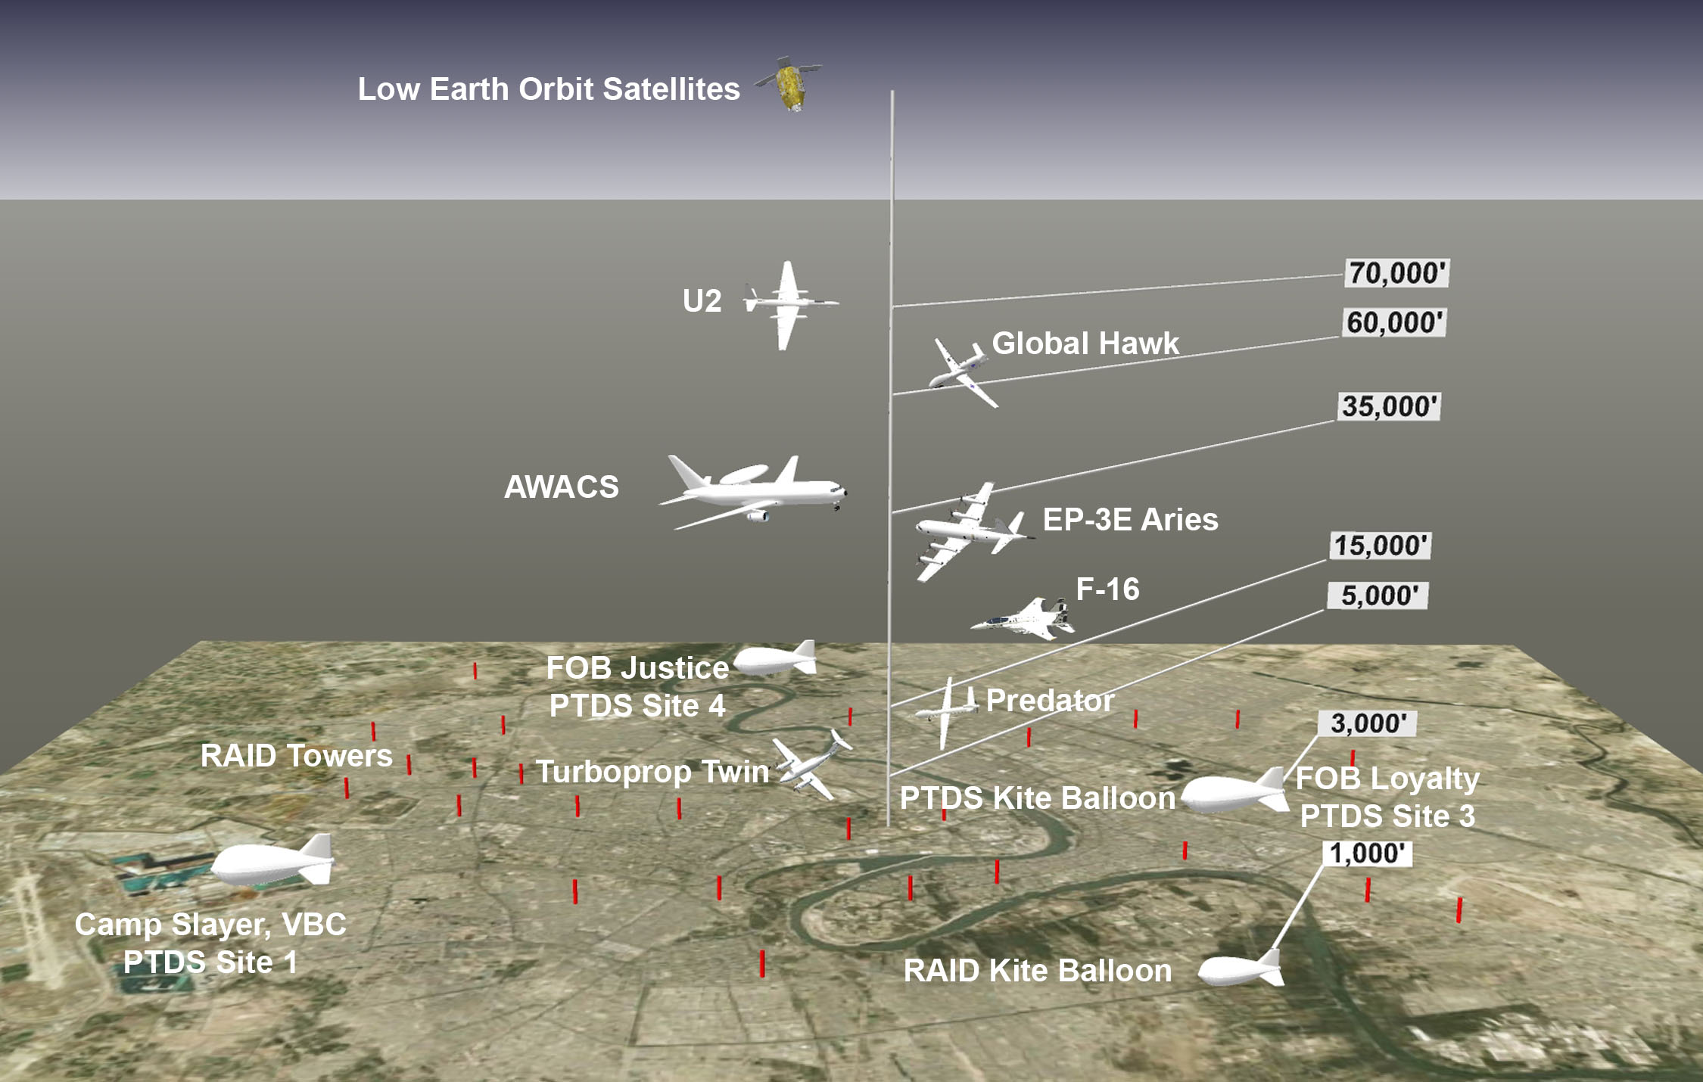
Strategic (National), Theater, Corps, Division, Brigade, Battalion & Company ISR Assets - Baghdad, 2007

Chapter 2 - Unprepared The unexpected and unknown. Sniper on FOB Justice. No mission training. System training. What we would be expected to do. A lesson plan. My career experience.

Because of OPSEC (Operational Security), and the possibility that people would back out, the company didn’t share many of the details of what life in the war zone would be like until the last minute. For example it wasn’t until a week before we were supposed to leave that we were told someone with a Russian sniper rifle had killed two-hundred people, almost all Iraqi civilians, on Forward Operating Base (FOB) Justice, our ultimate destination. That was offered in a briefing as they described the measures that would be taken to obscure the view of the mooring platform from outside the FOB.
I’d been in Florida with the other members of Team 4 training since February and until the existence of the sniper was revealed it hadn’t really sunk in that I’d be where I could actually be in someone’s gun sights. I should have known but I wasn’t prepared in that respect. That wasn’t anyone’s fault. I had just never been where those conditions existed. Winston had been and he was prepared. Since he’d been in the Army for twenty years I thought Jeff was too. I had no military or war zone experience but I assumed I would be able to adapt. Millions of men had done it before me. What bothered me more was the fact I didn’t know how to do my job. None of us did.
Our training didn’t include even a minute on anything resembling an actual mission. Our job was to float a balloon with cameras on it thousands of feet over Baghdad and somehow tell someone what we saw. We didn’t know how and since I was the team leader I worried about that. Fortunately, there was so much to do just to get there and get set up I wasn’t able to obsess about my worries.
The training that we did get in Florida was good in some respects. We assembled our system which meant setting up three 60 KW generators and the rest of the power distribution system, the Ground Control Station (GCS), the shelter from which we would operate the camera, and the Mooring Tower and Platform. We also inflated the one-hundred and ten feet long, fifty-six thousand cubic foot balloon and learned how to launch and recover it. Then we deflated it and packed it along with everything else for shipment aboard C-17s to Iraq.
All that was good but we knew almost nothing about how to actually conduct missions.
We knew we would be an integral ISR asset for Multinational Division Baghdad (MND-B). We knew we were to (DESCRIPTION REDACTED BY DOD) . We were going to look down on the battle-space and occupy the high ground in a way that had never been done before in the history of warfare. The fact that we weren’t told how to use the cameras to complete our historic task or how the Army would tell us what to look for and how we would tell them what we saw kept me awake at night. Raising my concern about the inadequate training was the source of my first conflict with my bosses.
At Lockheed’s offices at Port Canaveral and the Air Force proving range in Avon Park, Florida two men taught us what they knew about aerostat systems. Ken Sheridan knew quite a lot. He was Scott Jones’ assistant. Scott knew much less. He served on submarines which he told us quite a lot about. Scott was a funny guy, particularly good at imitating South Park characters and a good story-teller. Unfortunately far too much time was wasted on anecdotes during our training and I spoke up about it. First to Scott directly and then to Mike Nelson, the Operations Manager. Scott hadn’t been on the job long and he knew he wasn’t doing a great job with our training but it didn’t seem to bother him and he didn’t like it that I noticed.
After the first few days, when it became clear that a lot of details were being neglected, I wrote a lesson plan. It was a list of the things I was aware of that we had to do to get the system running and to conduct missions. Few of the items in the list had been taught and unless every available hour was put to good use we wouldn’t be adequately trained.
I was qualified to compile such a list because although I was a trainee on the PTDS project I was not a newcomer to complicated engineering projects, lighter-than-air or aerospace inflatables. My career in those fields began when I was twenty-five in 1980 and was interrupted in 1996. I’d helped inflate and operate many balloons and airships in those years. The first one was my father’s invention, a thing called the Cyclocrane. It was a hybrid airship, meaning it carried itself and the payload with both aerodynamic and aerostatic lift. After that I worked for RCA Aerostat Systems and was the project engineer on the Sea Based Aerostat System which was used by the U.S. Coast Guard for drug interdiction. The salvaged components from that program were used in the first PTDS system. Our division was bought by General Electric. Sometime after I left GE the LTA group, among others, was sold to Martin Marietta, which merged eventually with Lockheed. I left GE to become the production manager with American Blimp Corporation, then based in Seattle, and after that went to work as an engineer for ILC Dover, the firm that makes the aerostats and envelopes for many others. ILC also made the Apollo and Shuttle space suits, which I helped design and build.
Scott went over the outline with me but he didn’t use it. I asked Nelson to intervene but he didn’t get involved either so when we left for Baghdad there were huge gaps in our training and knowledge.

Chapter 33 - Urge To Jump Synopsis of the operational restrictions. How leaks are found and the time Ron Laniere and I are fired on during a leak inspection.

As soon as the wind stopped the tether tension dropped precipitously so I knew Don and I hadn’t patched all the holes in the balloon that first night, not by a long shot. There was still enough helium in the balloon to prevent the condition I feared but barely. To verify the alarmingly low tension reading on the GSHS screen I went up on the platform and pulled on the tether. I was able to pull the balloon down with one arm! With the lift that low, at the leakage rate we were suffering, the emergency would have happened within hours so once again we had to recover the balloon with little notice and the work that we were scheduled to do with the camera was cancelled. Fortunately, we weren’t supposed to do anything critical that night.
Kite balloons have been operated in difficult environments including the North Atlantic, the South Pole and other war zones but the conditions in the New Baghdad security district in the summer of 2007 were in many ways unique. You can’t recover a kite balloon anywhere if the wind is too high. Officially we weren’t supposed to launch or recover the balloon in winds greater than 20 knots. We couldn’t recover in daylight without drawing fire and if the tactical need was urgent, which it often was, the Army wouldn’t let us come “off-mission”. Finding out, when it’s too late, that there wasn’t enough helium in the balloon to stay aloft may never have happened before and I was almost the first flight director to have that dishonor.
Finding and repairing the leaks became an obsession. During the next six weeks we conducted seven leak inspections.
Ron Laniere and I went up to do the next one after that first night when Don and I did the repairs. This time both of us wore our helmets and vests. Ron wasn’t one of those fatalists who spoke of the bullet with his name on it.
Using the pressure washer we covered one panel at a time with soapy water to produce bubbles and reveal leaks. After finding and repairing several I became absorbed in the task and stopped worrying about the windows and shadows outside the wall. Finding a hole was a victory and with each we’d call down, “Found one!” And the others literally cheered.
A couple hours before daylight, with sweat pouring out from under the vest and helmet, just about the time when I’d stopped thinking about our location and the circumstances, we heard gunfire. Turning toward the sound we saw tracers coming over the wall near the guard tower and toward us. The same feeling I’d had when Winston and I were outside at Site One and a single round zipped by came over me but this time it was much worse. And I couldn’t take cover. The troops in the tower fired back and more rounds came in. Terror seized me and I had the urge to leap out of the basket just like those who jump from burning buildings. It was nearly irresistible and completely rational. Two broken legs seemed better than a rifle bullet in just about any part of my body. But rather than jump Ron and I made ourselves as small as we could as I swung the boom away from the balloon and took us down, at a sickening slow pace.
The rest of the crew ran behind T walls long before Ron and I got down. We joined them and talked about what had just happened and whether or not the balloon had more holes now.
We couldn’t wait much longer to go back out and launch the balloon. Sunrise was at 0430, which was less than two hours off.
The shooting stopped almost as soon as Ron and I got down. The BDOC told us the men in the towers couldn’t see anyone outside so it was probably over. We went back out and got the balloon up in time but we were worried that we were losing ground. If we drew fire during leak inspections we might never get ahead of the problem and we might also be killed. That possibility prompted one member of the crew, Mike Camp, to refuse to work above the wall. I wouldn’t have blamed them if they all had.

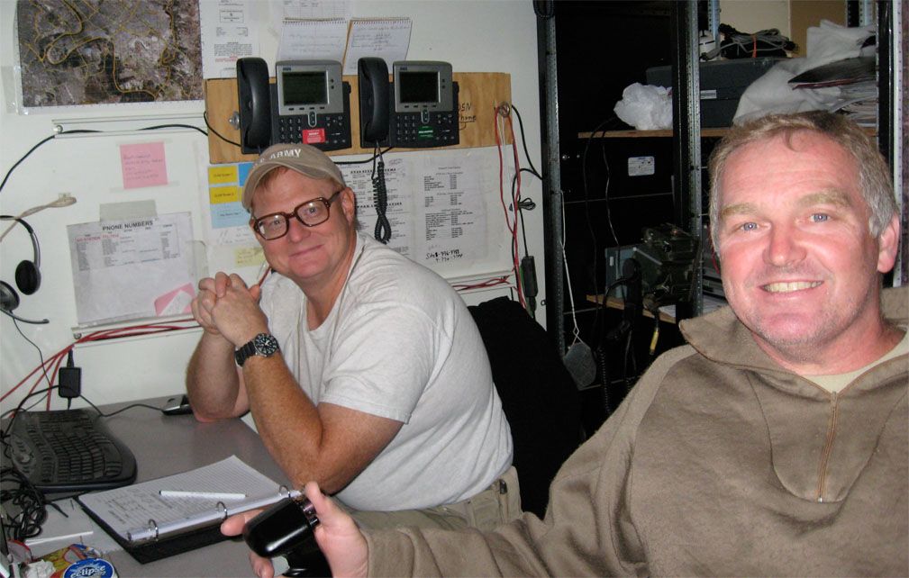
Dave Cole At The mIRC Station & Ron Lanier On The Camera

